|  |
| --- |
| Gulf Coast Joint Venture |
| Little Blue Heron Conservation Plan |
| A Product of the Gulf Coast Joint Venture Monitoring, Evaluation, and Research Team, Waterbird Working Group |
|  |
|  |
| **4/3/2016** |

|  |
| --- |
| Suggested Citation: Vermillion,W.G. 2016. Gulf Coast Joint Venture Little Blue Heron Conservation Plan. Gulf Coast Joint Venture, Lafayette, LA. 74 pp. |

**Gulf Coast Joint Venture Little Blue Heron Conservation Plan**

**Introduction**

In 1986, faced with significant, unabated wetland loss and declines in waterfowl populations, the Canadian and United States (U.S.) governments signed the North American Waterfowl Management Plan (NAWMP; U.S. Department of the Interior and Environment Canada, 1986). The plan provided a strategy for wetland conservation and restoration, set waterfowl population targets, identified priority areas for waterfowl conservation actions, and described a collaborative conservation model, Joint Ventures, for plan implementation. North American bird habitat Joint Ventures are regional partnerships composed of individuals, corporations, conservation organizations, and local, state, provincial, and federal agencies concerned with conservation of migratory birds and their habitat in a particular physiographic region. Due to its importance for migrating and wintering waterfowl, and for breeding Mottled and whistling ducks, the western U.S. Gulf of Mexico was identified as a priority area for NAWMP implementation, and the Gulf Coast Joint Venture (GCJV) was established. With the subsequent publication of the North American Landbird Conservation Plan, the U.S. Shorebird Conservation Plan, and the North American Waterbird Conservation Plan, North American bird habitat Joint Ventures were identified as the appropriate entities to implement those plans. The GCJV selected a subset of landbirds, shorebirds, and waterbirds for conservation action in the region. Little Blue Heron is one of eight waterbird species selected by the Waterbird Working Group of the GCJV Monitoring, Evaluation, and Research Team for conservation action using the Strategic Habitat Conservation model (National Ecological Assessment Team, 2006).

**Species Description**

The Little Blue Heron *(Egretta caerulea)* is a medium-sized heron in the family Ardeidae, which includes bitterns, herons, and egrets. It is a colonial nesting waterbird, typically inhabiting mixed-species nesting colonies of other ardeids and species such as White Ibis *(Eudocimus albus)* and Anhinga *(Anhinga anhinga)*. It breeds in the southeastern and south-central United States, along the Atlantic seaboard as far north as Maine, the West Indies, the Pacific and Gulf coasts of Mexico and Central America, and in South America in Columbia, Venezuela, the Guianas, Brazil, and Uruguay (Knoder et al. 1980, American Ornithologists’ Union 1983, Rodgers and Smith 2012). In North America, most of the breeding population moves south post-breeding in fall to overwinter along the southern U.S. Atlantic and Gulf coasts, coastal Mexico, the West Indies, and South America (Rodgers and Smith 2012). Both adults and nestlings exhibit post-breeding dispersal away from nesting colony sites, often northward, prior to migrating south for winter (Coffey 1943, Dusi 1957, 1967, Byrd 1978). The GCJV region (Figure 1) hosts birds year round and is a very important breeding and wintering area for the species (Root 1988, Hunter et al. 2006, Sauer et al. 2014).

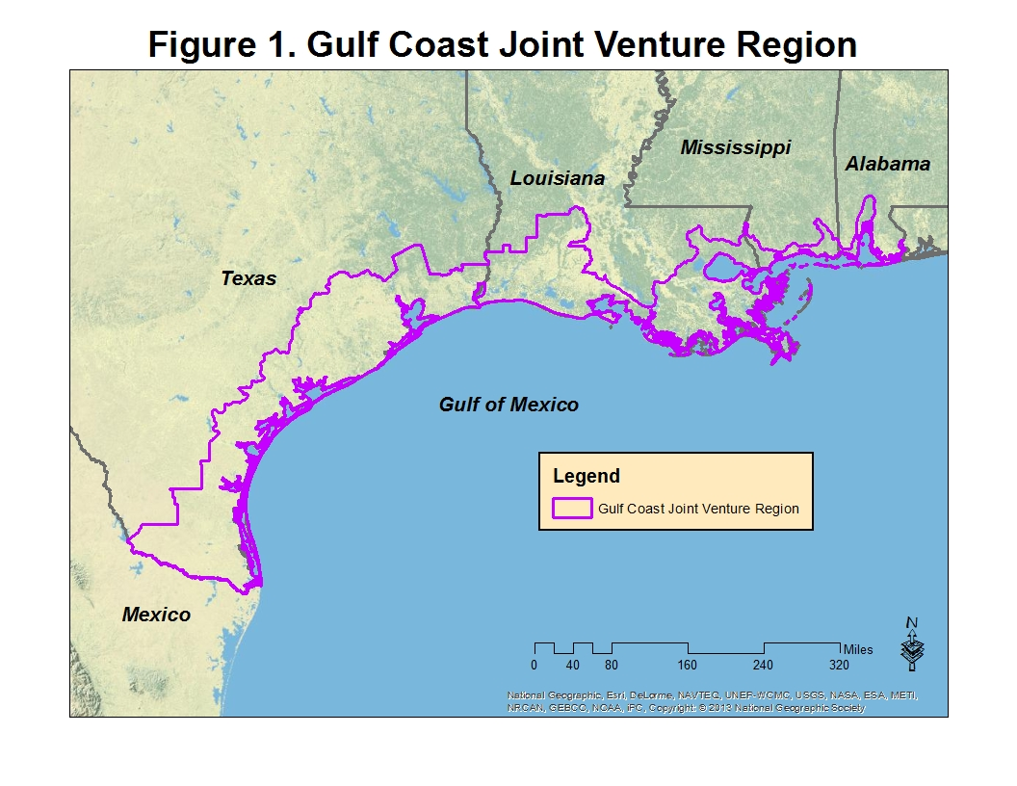

Hamel (1992) described Little Blue Heron as a bush or tree nesting, aquatic stalking carnivore. Typical GCJV region nesting colony sites are in flooded freshwater forested and scrub-shrub wetlands, as well as islands vegetated with woody shrubs and small trees. In forested wetlands, the species tends to select shrubs and small trees below the canopy layer; nest height above water averages from about 0.5 to 2 m (~1.6 to 6.5’) (Meanley 1955, Burger 1978b, Rodgers 1980, Rodgers and Smith 2012). The nesting season in the GCJV region spans from approximately mid-March to mid-August. Birds can breed their first year post-hatching at age 10 to 12 months (Rodgers and Smith 2012). The species is single-brooded, but females will replace lost clutches (Rodgers and Smith 2012). Typical clutch size is 3 to 4 eggs; nestlings fledge at about 5 weeks of age (Rodgers and Smith 2012).

Little Blue Herons forage in a range of habitat types, including freshwater and estuarine emergent wetlands, flooded forested wetlands, rice *(Oryza* L.*)* fields, crawfish *(Procambarus spp.)* ponds, and uncommonly in pastures (Jenni 1969, Fleury and Sherry 1995, DuBowy 1996, Rodgers and Smith 2012). Common prey items include fish, crustaceans, and frogs. The species often uses densely vegetated aquatic habitats, with water depths between 5 to 15 cm (~2 to 6”) (Jenni 1969, Willard 1977). During breeding season, most foraging occurs within approximately 10 km (~ 6.2 mi) of the colony site (Custer and Osborn 1978, Bancroft et al. 1990, Rodgers and Smith 2012), but in some settings foraging apparently occurs at considerably greater distances from nesting sites (Brent Ortego, Texas Parks and Wildlife Department, personal communication).

**Conservation Status**

The Little Blue Heron is a priority waterbird species identified for habitat conservation planning and implementation by the GCJV partnership. It is classified as a Species of High Concern in the North American Waterbird Conservation Plan, signifying a species known or believed to be declining, with additional known or potential threats to its population (Kushlan et al. 2002). Similarly, the Southeast United States Regional Waterbird Conservation Plan (SEUS Waterbird Plan) (Hunter et al. 2006) ranks Little Blue Heron as a “Continental and Regional Concern Species requiring Immediate Action because of demonstrable declines over most of its range in the U.S.” The relative paucity of historic and accurate data hinders population trend analysis; however, Breeding Bird Survey trend analysis for 1996 to 2013 indicates a significant increase in the Gulf Coastal Prairie physiographic region, which comprises the majority of the GCJV region, but indicates a significant decrease survey-wide in North America (Rodgers and Smith 2012, Sauer et al. 2015).

**Primary Factors Limiting Population**

Rodgers and Smith (2012) believed that the main limiting factor to population growth range-wide was alteration of foraging habitat and therefore food availability, limiting nestling and adult survival. Along those lines, Hunter et al. (2006) opined that declines could be related to loss of riparian forested wetlands from conversion to other habitat types such as agriculture and reservoir impoundments. Predation at nesting colony sites can occasionally cause significant nest failure (Parsons 1994, Olmos and Silva e Silva 2002), but the species’ preference for nesting over water generally limits effects from mammalian predators (Rodgers and Smith 2012). However, availability of flooded shrub swamp nesting sites may be limiting the population in some areas, such as in Texas, which has experienced significant precipitation deficits during the last several years (Brent Ortego, Texas Parks and Wildlife Department, personal communication). American Crows *(Corvus brachyrhynchos)* caused failure of a large Texas colony of Little Blue Heron and Snowy Egret *(Egretta thula)* (Baker 1940). Anecdotal evidence suggests that the Little Blue Heron population may be negatively impacted through competition with Cattle Egret *(Bubulcus ibis)* for nest sites, yet Little Blue Herons have expanded into the midwestern U.S coincident with a similar expansion by Cattle Egrets (Dusi 1968, Rodgers and Smith 2012). Little Blue Herons are also subject to infection by the nematode *Eustrongylides ignotus* which has caused die-offs of nestling ardeids (Weise et al. 1977, Roffe 1988), and reduced fitness in birds with lower infestation rates (Spalding et al. 1993).

Based on available literature and expert opinion, the GGJV Waterbird Working Group assumes that the availability, or lack thereof, of suitable foraging habitat adjacent to suitable nesting habitat is the strongest influence on Little Blue Heron populations in the GCJV region.

**Current Population Estimate and Population Objective**

The global population of Little Blue Heron is estimated at between 150,000 – 245,000 pairs (450,000 – 735,000 individuals, accounting for non-breeders) (Butler et al. 2000, Morales 2000). However, Kushlan et al. (2002) deemed there was insufficient information to derive a reasonable population estimate for North and Central America. Hunter et al. (2006) solicited population estimates from southeastern U.S. state and federal wildlife biologists and surmised that the population in that region was in the range of 40,000 to >60,000 pairs. The GCJV Waterbird Working Group reviewed population estimates and objectives from the SEUS Waterbird Plan, stepped down to the GCJV region, but were uncomfortable with the high level of uncertainty associated with those estimates. Instead, the group used the most complete and recent dataset for the GCJV region, which was from 2004-2005, when Little Blue Heron colonies were surveyed in both Texas and Louisiana (Louisiana Department of Wildlife and Fisheries, Louisiana Natural Heritage Program, unpublished data; Texas Parks and Wildlife Department, unpublished data; Texas Colonial Waterbird Society, unpublished data). Similar surveys were not conducted in either Mississippi or Alabama for that time period, so the respective state wildlife biologists were consulted to derive an expert opinion-based population estimate for those two states. Data from Texas and Louisiana included a combination of ground-based counts along with aerial surveys from fixed-wing aircraft. A detection probability of 0.81 derived by Green et al. (2008) was applied to ground counts. For aerial surveys, a detection probability of 0.59, also derived from Green et al. (2008) was used. Although this factor was not calculated for fixed-wing aerial surveys, it is similar to a presence/absence detection probability of 0.57 derived by Rodgers et al. (2005) for aerial surveys of Little Blue Heron in Florida.

The population estimate generated for the GCJV region using the data described above is 21,266 pairs (Table 1). The population objective for Little Blue Heron in the GCJV region is to increase the breeding population by 30 percent (Tables 1 and 2). This population objective is based upon proposed Little Blue Heron objectives in the SEUS Waterbird Plan (Hunter et al. 2006) and reflects an average of the percent increases proposed for the four bird conservation regions that comprise the GCJV region.

**Table 1. Little Blue Heron Population Estimates and Objectives, by State,**

**GCJV Region**

|  |  |  |
| --- | --- | --- |
| **State** | **Population Estimate (Pairs)** | **Population Objective (Pairs)** |
| Alabama | 50 | 65 |
| Louisiana | 10,364 | 13,471 |
| Mississippi | 24 | 31 |
| Texas | 10,828 | 14,071 |
| Total | 21,266 | 27,638 |

Numerous conservation measures were identified as having the potential to increase Little Blue

Heron populations in the GCJV region. They are described below, and grouped according to

whether they primarily affect foraging habitat, nesting habitat, chick survival, or adult survival.

Data from state and federal agencies were used to identify colony sites throughout the GCJV region. These sites and associated foraging areas were grouped according to GCJV Initiative Area (Figure 2) and the most important conservation measures were identified for each colony or collection of colonies. Population objectives for GCJV Initiative Areas are listed in Table 2. Initiative Area objectives were allocated according to relative proportions of nesting Little Blue Herons recorded in each area during 2004-2005 surveys.

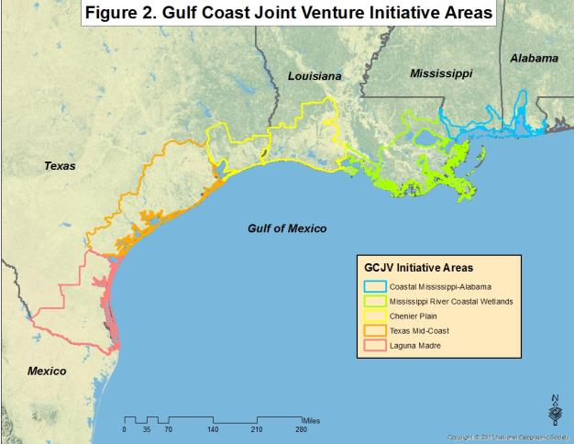

**Table 2. Little Blue Heron Population Objectives by GCJV Initiative Area**

|  |  |
| --- | --- |
| **Initiative Area** | **Population Objective (Pairs)** |
| Laguna Madre | 164 |
| Texas Mid-Coast | 5,345 |
| Chenier Plain, Texas Portion | 8,562 |
| Chenier Plain, Louisiana Portion | 7,217 |
| Mississippi River Coastal Wetlands | 6,254 |
| Coastal Mississippi - Alabama | 96 |
| Total | 27,638 |

**Proposed Conservation Measures to Achieve Population Objectives**

**Protect Foraging Habitat**

**Conserve forested and emergent wetlands, especially adjacent to (≤ 10 km) colonies –** Little Blue Herons typically forage in shallowly-flooded (5 to 15 cm deep) forested or emergent wetlands (Jenni 1969, Willard 1977, Fleury and Sherry 1995, DuBowy 1996, Rodgers and Smith 2012). During the nesting season, most foraging takes place within approximately 10 km of colony sites (Custer and Osborn 1978, Bancroft et al. 1990, Rodgers and Smith 2012). State and federal natural resource agencies should maintain datasets of Little Blue Heron and other waterbird colonies to enable review of proposed wetland projects (i.e., construction, flood protection, navigation facilitation) to ensure that foraging needs of waterbirds are considered when determining preferred project alternatives. Projects and management actions that protect existing foraging habitat, especially near important waterbird colonies, should be a priority. These projects could include acquisition of important habitat, negotiated conservation easements, and emergent marsh erosion control measures.

**Maintain existing rice and crawfish production areas, especially adjacent to (≤ 10 km) colonies –** The value of rice and crawfish production areas as foraging areas for waterbirds has been noted by researchers (Fleury and Sherry 1995, Elphick et al. 2010, Sizemore and Main 2012). Rice acreage has declined in the GCJV region over the last several decades, especially in Texas, where conflicting demands for water resources have limited allocations for irrigation (USDA, National Agricultural Statistics Service 2013, Ducks Unlimited 2013). Acres in crawfish (crayfish) production in the GCJV region have increased over the last several decades. In Louisiana, acres devoted to crawfish aquaculture increased from 18,842 hectares (46,562 acres) in 1978 to 76,833 hectares (189,860 acres) in 2011 (LSU AgCenter 2013). Conservation of these systems is typically beyond the bounds of most conservation organizations, as they are driven by supply and demand and availability of water. However, where appropriate conservation organizations can voice support for, or contribute financial or technical assistance to programs such as Farm Bill incentives for rice and crawfish producers. Of greatest value are incentives that increase waterbird benefits, such as holding water on crawfish ponds post-harvest to allow slow evaporative drawdown, which can concentrate prey for foraging herons.

**Restore Foraging Habitat**

**Restore natural hydrologic regimes in forested and emergent wetlands** - Waterbirds select nesting sites on the basis of protection from predators and access to foraging habitat. In unaltered systems in the southeastern United States, winter and spring precipitation typically flood woody and emergent wetlands. Water levels decrease with the onset of higher evapotranspiration and reduced precipitation in summer months, concentrating prey resources for adults, dependent young, and fledged chicks. However, many of these wetland systems have been altered through flood control efforts, navigation engineering, impoundment for recreational or agricultural water use, etc., and favorable foraging habitat has been reduced or eliminated as a result. Projects and management regimes that restore or mimic natural wetland flooding and drying cycles should be priorities, especially when they provide shallow (5 to 15 cm deep) foraging habitat within 10 km of active Little Blue Heron nesting colonies. Large-scale freshwater diversions may also restore and enhance Little Blue Heron foraging habitat, by mimicking spring flood pulses with subsequent summer drying.

**Restore forested wetlands and/or scrub-shrub swamps at previously converted sites** – Programs such as the U.S. Department of Agriculture (USDA), Natural Resources Conservation Service’s Wetlands Reserve Program (WRP) have restored millions of acres of wetlands on previously cleared agricultural lands in North America (USDA, Natural Resources Conservation Service 2013). Agreements created through conservation programs often include reforestation and water management components (i.e. using water control structures to hold water in areas). Hydrologic regimes in restored wetlands should mimic the natural flood-dry cycle to produce prey items for foraging birds.

**Create Foraging Habitat**

**Encourage and support utilization of Farm Bill and similar conservation incentive programs to provide appropriately flooded and manipulated agricultural fields during breeding periods within foraging radii of nesting colonies** – As described above, the value of flooded agricultural fields and crawfish aquaculture to waterbirds has been well documented. Conservation programs administered by the USDA (and other agencies and organizations) provide agricultural producers with incentives for implementing beneficial practices on their lands. Several practices are intended to enhance habitat for wildlife species. Many state wildlife agencies include private lands biologists on staff, whose mission is to aid citizens with wildlife management planning and implementation. In some states, these biologists also work in concert with USDA staff to implement wildlife-friendly practices. Management of wetlands for waterbirds should be among the list of options provided to producers and other private landowners by agency biologists.

**Manipulate water regimes at moist-soil units on conservation lands to benefit foraging breeding and non-breeding birds –** Many federal, state, and privately-owned wildlife refuges and management areas contain moist-soil impoundments managed to provide waterfowl foraging habitat. Manipulating water levels on moist-soil impoundments can provide conditions to produce fish, crustacean, and anuran prey for Little Blue Herons during critical life cycle periods. Providing water depths between 5 to 15 cm when adults are breeding and feeding nestlings may increase nestling survival and fledging rates (Rodgers and Smith 2012). Martin and Lester (1991) defined the incubation season in Louisiana for Little Blue Heron from approximately 16 March to 15 June, and estimated 28 to 32 days to fledging. Therefore, impoundments managed to provide suitable foraging conditions from mid-March to early August should provide resources to breeding Little Blue Herons. Fredrickson and Taylor (2007) stated that herons preferred impoundments with abundant floating or submerged vegetation, and some emergent vegetation, provided it did not restrict visibility. They suggested a combination of spring drawdowns and summer flooding, using multiple impoundments, to provide habitat for herons and other wading birds, while providing opportunities for regeneration of moist-soil plants important to waterfowl. Because Little Blue Herons disperse post-breeding, managed impoundments that are not within the typical foraging radius of breeding adults can provide resources to post-breeding adults and post-fledging young of year. The approximate time range for post-breeding dispersal, and subsequent fall migration, for the GCJV region spans from mid- to late August into mid-October (Lowery 1974, Rodgers and Smith 2012). Also, important wintering foraging habitat can be provided on moist-soil impoundments.

**Establish moist-soil units on conservation lands where appropriate to provide foraging habitat for breeding birds –** The opportunities to establish moist-soil units managed for Little Blue Herons and other wetland species should be investigated, especially within the foraging radii of known breeding areas. As described in the preceding section, these units are also of value outside the breeding season, when birds disperse from colonies prior to southbound migration, and during the migration and wintering periods as well.

**Create emergent wetlands via marsh creation and river diversion projects –** Loss of emergent wetlands along the Gulf Coast has been and continues to be significant. Creation of emergent marsh through dredged sediment deposition can provide foraging habitat for Little Blue Herons and other wetland-dependent birds. Similarly, diversions of sediment-laden freshwater from rivers into open water or degraded marsh can create deltaic splays and emergent marsh foraging habitat that is valuable to Little Blue Herons and associated species.

**Protect Nesting Habitat**

**Prevent conversion of forested wetland colony sites –** Though many forested and scrub-shrub wetlands are protected under the Clean Water Act, this protection does not necessarily ensure that important nesting sites cannot be converted for other uses, such as recreational development, or oil and gas exploration and production. State and federal permitting agencies should prioritize important waterbird rookery sites for protection and seek alternatives when these sites are proposed for development. This requires current databases depicting colony locations and size (nesting pair) estimates.

**Reduce erosion at island colony sites** – Little Blue Herons often nest in mixed species colonies on coastal islands. Many of these islands have experienced reductions in area due to erosion from vessel wakes, storms, etc. There are several engineering solutions designed to reduce wave-driven erosion that can be utilized at important Little Blue Heron nesting islands, including shoreline armoring and installation of manufactured or living reefs adjacent to islands. The GCJV Reddish Egret Conservation Plan (Vermillion and Wilson 2009), and Chaney and Blacklock (2005) identify some sites hosting Little Blue Herons that are in need of erosion protection.

**Restore Nesting Habitat**

**Restore altered hydrologic regimes at forested wetland colony sites –** As described above, wading birds select nesting sites based upon a combination of protection from predation and disturbance, and access to food resources. Natural hydrologic cycles in the southeastern U.S. provide flooded swamps during nesting season, and as summer progresses, adjacent wetlands dry out and concentrate prey, providing food resources for adults feeding young. However, these natural hydrologic cycles have been altered in many areas through impoundment, stream channelization, and flood control measures such as levees. Projects that improve or restore natural flooding-drying processes in forested and scrub-shrub wetlands hosting Little Blue Heron colonies should be a priority.

**Add dredged material to island sites** – Important island nesting colony sites that have lost area due to erosion, subsidence, or relative sea level rise should be enhanced through deposition of dredged material. The GCJV Reddish Egret Conservation Plan (Vermillion and Wilson 2009), and Chaney and Blacklock (2005) identify some sites hosting Little Blue Herons that are in need of dredged material deposition.

**Restore forested wetlands and scrub-shrub swamps at previously converted sites** – Programs such as the WRP have restored millions of acres of wetlands on previously cleared agricultural lands in North America (USDA, Natural Resources Conservation Service 2013). Agreements under the WRP often include reforestation and water management components (i.e. using water control structures to hold water in areas). Waterbirds have been documented using WRP restoration sites as colony locations (USDA, Natural Resources Conservation Service 2013). As described above, hydrologic regimes in restored wetlands should mimic the natural flood-dry cycle to provide protection from mammalian predators, and to furnish prey items for adults and young.

**Plant shrubs at colony sites** – Mechanical action of twig removal for nest building by waterbirds, along with chemical effects of guano may reduce or eliminate availability of nesting substrate for Little Blue Herons. Also, dredged material islands may lack woody plants suitable for nest construction. These sites can be enhanced through shrub plantings to increase availability of nesting substrate for Little Blue Herons and other waterbirds. Little Blue Herons use a variety of plants as nesting substrate, including buttonbush *(Cephalanthus occidentalis)* and black mangrove *(Avicennia germinans)*, but nesting substrate species is less important than the plant’s ability to support the nest structure (Rodgers and Smith 2012). The GCJV Reddish Egret Conservation Plan (Vermillion and Wilson 2009), and Chaney and Blacklock (2005) identify some sites in need of vegetation management.

**Create Nesting Habitat**

**Create islands using dredged material –** Islands created from dredged materials are important sites for colonial nesting waterbirds (Hunter et al. 2006). Depending upon their location, created islands can be free from mammalian predators, and experience little human disturbance. Hunter et al. (2006) summarized recommendations for colonial nesting waterbird island creation, and suggested that created islands be at least 2 km (~1.2 miles) from the mainland and separated by a deep channel or in an area subject to tidal movement. Soots and Landin (1978) and Landin (1986) suggested that islands created for nesting waterbirds should range from 2 to 20 hectares (ha) (~5 to 49 acres) in size. A cursory Geographic Information System analysis (using the 2006 National Landcover Database) of Little Blue Heron island nesting colony sites active since 2000 in Texas and Louisiana indicated that the average island colony site size was approximately 23 ha (~57 acres), with a range from less than 1 ha (~2.5 acres) to slightly more than 133 ha (~329 acres). Average distance from the mainland for these sites was approximately 3.4 km (~2 miles), with a range of less than 1 km to nearly 11 km (~0.6 to 7 miles). On the North Carolina coast, Soots and Parnell (1975) estimated that created island sites would not be used by wading birds until the sites were approximately 10 years old or more, due to the time required for woody plant establishment. This time period can be truncated by planting woody shrub and small tree species on created islands.

Hafner (1982) described creation of an artificial island on previously farmed land in France. The site was surrounded by a created emergent wetland and planted in native trees. Once the vegetation matured sufficiently to support nest platforms (approximately 10 years) managers used a combination of captive egrets from a local zoo, decoys, decoy nests, and recorded calls to successfully attract birds to nest on the site.

**Increase Chick and Adult Survival**

**Reduce or eliminate human disturbance at colony sites –** Human disturbance at colony sites can lead to site abandonment, egg and chick mortality, and reduced growth rates (Rodgers and Smith 2012). Where possible, buffer zones around Little Blue Heron nesting colonies should be established and enforced, through a combination of signage, outreach, and protection via wildlife enforcement agents or non-governmental conservation wardens, such as those that have been utilized by the National Audubon Society. Erwin (1989) and Rodgers and Smith (1995) recommended a 100 m (~328 feet) buffer zone around wading bird colonies to protect them from disturbance from humans on foot. More conservatively, Martin and Lester (1991) recommended a 300 m (~984 feet) buffer zone around wading bird nesting colonies. The GCJV Reddish Egret Conservation Plan (Vermillion and Wilson 2009), and Chaney and Blacklock (2005) identify some sites in need of human disturbance management.

**Reduce predation at colony sites –** Whereas normally occurring at relatively low rates, predation can cause significant losses under certain conditions. Island sites that are colonized by mammalian predators or red imported fire ants *(Solenopsis invicta)* can suffer significant diminishment in breeding success (David Newstead, Coastal Bend Bays and Estuaries Program, personal communication). Control of predators can increase nest and fledging success at afflicted colonies (Erwin and Beck 2007). The GCJV Reddish Egret Conservation Plan (Vermillion and Wilson 2009), and Chaney and Blacklock (2005) identify some sites in need of predator management.

The presence of American alligators *(Alligator mississippiensis)* near waterbird colonies may deter mammalian predators (Burtner 2011). Newsom et al. (1987) developed a habitat suitability index for American alligator. Optimal alligator habitat in ponds and lakes was defined as having 20 to 40% open water at least 15 cm (~6 inches) deep, with 10 to 20% of the open water deeper than 1.2 m (~4 feet). Sites should be flooded from May through September. Alligators prefer areas with high vegetation to water interspersion; Newsom et al. (1987) defined high interspersion as 10 to 15 open water areas >0.2 ha (~0.5 acres) in size per 6 ha (~15 acres) of wetland area.

**Reduce disturbance at foraging sites –** Foraging Little Blue Herons demonstrate altered behavior, such as reduced prey capture attempts, when humans are in the proximity (Burger and Gochfeld 1998). Rodgers and Smith (1997) looked at flushing distances of foraging or loafing Little Blue Herons and recorded the following information for various types of human disturbance:

**Table 3. Little Blue Heron Flushing Distances (Rodgers and Smith 1997)**

|  |  |  |
| --- | --- | --- |
| **Type of Disturbance** | **Range of Flushing Distances (meters, m)** | **Mean Flushing Distance (Sample Size)** |
| Pedestrians | 5-45 m | 22±14 m (n=20) |
| Personal Watercraft | 16-111 m | 37.3±15.2 m (n=66) |
| Outboard Motor-Powered Watercraft | 16-108 m | 49.3±22.2 m (n=51) |
| Airboats | NA | 89±34 m (n=80) |

As a result of these studies the authors recommended buffer zones of 100 to 200 m (~328 to 962 feet) to reduce disturbance to Little Blue Herons. Establishment of no-entry zones around areas that provide important foraging habitat for waterbirds should be a consideration on public and privately-owned conservation lands.

**Science Needs**

The GCJV is currently compiling and prioritizing science needs for waterbirds, shorebirds, and landbirds to guide research and monitoring efforts over the next 5 – 10 years. At a 2015 meeting of the GCJV Waterbird Working Group, the following science needs relevant to Little Blue Heron were identified:

1. Validate response of priority colonial nesting waterbirds to colony site management measures, including erosion control, dredged material placement, vegetation management, disturbance minimization, and predator control.
2. Assess status and distribution of Little Blue Herons in the GCJV region, employing a standard repeatable methodology, incorporating detection probabilities, which can be used across the region by individual states or other partners.

**Initiative Area Plans**

Using data from the Texas Colonial Waterbird Survey, the Louisiana Department of Wildlife and Fisheries Natural Heritage Program, the U.S. Geological Survey, and other sources, historic and extant (i.e., from the mid-1970’s to the present) nesting colony sites for Little Blue Heron were identified. It should be noted that the data obtained on colony sites and foraging areas may be incomplete for some areas. It is envisioned that this document would be updated on a 5-10 year schedule, which would allow for incorporation of new sites and elimination of abandoned ones. Assuming that most foraging takes place with 10 km of colony sites (Custer and Osborn 1978, Bancroft et al. 1990, Rodgers and Smith 2012), sites were buffered with 10 km putative foraging radii to create polygons containing colony sites and associated foraging habitat. Where foraging areas overlap, sites have been grouped into clusters based upon contiguous foraging habitat. Coastal Change Analysis Program landcover data (2005) were clipped to those polygons to enable identification of available foraging habitat, with the goal of identifying strategies to maintain and increase populations of Little Blue Herons through combinations of the actions described above. Table 4 lists the Initiative Area nesting and foraging polygons with identified conservation strategies. Maps depicting those polygons are provided below, grouped by Initiative Area.

|  |  |  |  |  |  |  |  |  |  |  |  |  |  |  |  |  |
| --- | --- | --- | --- | --- | --- | --- | --- | --- | --- | --- | --- | --- | --- | --- | --- | --- |
| Table 4. Recommended Conservation Actions by Cluster | | | | | | | | | | | | | | | | |
| Initiative Area | Cluster Name | Est. LBHE Pairs 2004-20051 | Protect Foraging and Nesting Habitat | | | Restore Foraging and Nesting Habitat | | | | Create Foraging and Nesting Habitat | | | | | Increase Chick and Adult Survival | |
| Maintain Existing Woody and Emergent Wetlands | Maintain Rice-Crawfish Systems | Reduce Erosion at Island Colony Sites | Restore Hydrologic Regimes | Restore Prior Converted Woody Wetlands | Add Dredged Material to Island Colony Sites | Plant Shrubs at Colony Sites | Provide Foraging Habitat Through Incentive Programs | Manage Impoundments on Conservation Lands for Foraging LBHE | Establish Impoundments on Conservation Lands for Foraging LBHE | Create Emergent Wetlands | Create Nesting Islands | Reduce or Eliminate Human Disturbance at Colonies and Foraging Sites | Reduce Predation at Colonies |
| Laguna Madre (Fig 3.) | Lower Laguna Madre (Fig. 4) | 86 | X |  | X | X | X | X | X |  | X | X | X | X | X | X |
| Guadalupe to Baffin Bay, Laguna Madre Portion (Fig. 5) | 38 | X |  | X | X | X | X | X |  | X | X | X | X | X | X |
| Wright Gravel Pits (Fig. 6) | 3 | X |  |  | X | X |  |  | X |  |  |  |  |  |  |
| King Ranch (Fig. 7) | Unknown2 |  |  |  |  |  |  |  |  |  |  |  |  |  |  |
| Texas Mid-Coast (Fig. 8) | East Matagorda Bay (Fig. 9) | 1694 | X |  | X | X |  | X |  | X | X | X | X | X | X | X |
| Brazos River Wetlands (Fig. 10) | 1410 | X |  |  | X | X |  |  | X | X | X | X | X | X | X |
| Guadalupe to Baffin Bay, Texas Mid-Coast Portion (Fig. 11) | 504 | X | X | X | X | X | X | X | X | X | X | X | X | X | X |
| Lavaca Bay Islands (Fig. 12) | 434 | X | X | X | X |  | X |  | X | X |  | X | X | X | X |
| Sheldon Lake (Fig. 13) | 53 | X |  |  | X |  |  |  |  | X |  |  |  | X | X |
| Sabine-Trinity-San Bernard, Texas Mid-Coast Portion (Fig. 14) | 19 | X | X | X | X | X | X | X | X | X | X | X | X | X | X |
| Eagle Lake (Fig. 15) | unknown | X | X |  | X | X |  |  | X |  |  |  |  |  |  |
| Fennessey Ranch (Fig. 16) | unknown | X |  |  | X | X |  |  | X |  |  |  |  |  |  |
| 12004-2005 data used to generate population estimate and objective | | | | | | | | | | | | | | | | |
| 2Monitor future conditions and develop plan if LBHE present | | | | | | | | | | | | | | | | |

|  |  |  |  |  |  |  |  |  |  |  |  |  |  |  |  |  |
| --- | --- | --- | --- | --- | --- | --- | --- | --- | --- | --- | --- | --- | --- | --- | --- | --- |
| Table 4. Recommended Conservation Actions by Cluster | | | | | | | | | | | | | | | | |
| Initiative Area | Cluster Name | Est. LBHE Pairs 2004-20051 | Protect Foraging and Nesting Habitat | | | Restore Foraging and Nesting Habitat | | | | Create Foraging and Nesting Habitat | | | | | Increase Chick and Adult Survival | |
| Maintain Existing Woody and Emergent Wetlands | Maintain Rice-Crawfish Systems | Reduce Erosion at Island Colony Sites | Restore Hydrologic Regimes | Restore Prior Converted Woody Wetlands | Add Dredged Material to Island Colony Sites | Plant Shrubs at Colony Sites | Provide Foraging Habitat Through Incentive Programs | Manage Impoundments on Conservation Lands for Foraging LBHE | Establish Impoundments on Conservation Lands for Foraging LBHE | Create Emergent Wetlands | Create Nesting Islands | Reduce or Eliminate Human Disturbance at Colonies and Foraging Sites | Reduce Predation at Colonies |
| Texas Mid-Coast, Continued (Fig. 8) | Lake Texana (Fig. 17) | unknown | X | X |  | X | X |  |  | X |  |  |  |  | X |  |
| Morton Road Rookery (Fig. 18) | Unknown2 |  |  |  |  |  |  |  |  |  |  |  |  |  |  |
| Texas Chenier Plain (Fig. 19) | Sabine-Trinity-San Bernard, Texas Chenier Plain Portion (Fig. 20) | 6587 | X | X | X | X | X | X |  | X | X | X | X | X | X | X |
| Mann-Merchant Road (Fig. 21) | unknown | X | X |  | X | X |  |  | X |  |  |  |  |  |  |
| Louisiana Chenier Plain (Fig. 22) | Miller’s Lake (Fig. 23) | 4103 | X | X |  | X | X |  |  | X |  |  |  |  | X | X |
| Bayou Serpent (Fig. 24) | 493 | X | X |  | X | X |  |  | X |  |  |  |  |  |  |
| Lower Vermilion (Fig. 25) | 289 | X | X |  | X | X |  |  | X | X | X | X |  | X | X |
| Cameron-Creole (Fig. 26) | 288 | X | X |  | X | X |  |  | X | X | X | X | X | X | X |
| Rabbit Island (Fig. 27) | 282 | X |  | X | X |  | X | X |  | X | X | X | X | X | X |
| Black Lake (Fig. 28) | 78 | X | X |  | X | X |  |  | X |  | X | X | X | X |  |
| Sabine-Trinity-San Bernard, Louisiana Chenier Plain Portion (Fig. 29) | 18 | X |  |  | X | X |  |  |  |  | X | X |  | X | X |
| Queue de Tortue (Fig. 30) | Unknown2 |  |  |  |  |  |  |  |  |  |  |  |  |  |  |
| 12004-2005 data used to generate population estimate and objective | | | | | | | | | | | | | | | | |
| 2Monitor future conditions and develop plan if LBHE present | | | | | | | | | | | | | | | | |

|  |  |  |  |  |  |  |  |  |  |  |  |  |  |  |  |  |
| --- | --- | --- | --- | --- | --- | --- | --- | --- | --- | --- | --- | --- | --- | --- | --- | --- |
| Table 4. Recommended Conservation Actions by Cluster | | | | | | | | | | | | | | | | |
| Initiative Area | Cluster Name | Est. LBHE Pairs 2004-20051 | Protect Foraging and Nesting Habitat | | | Restore Foraging and Nesting Habitat | | | | Create Foraging and Nesting Habitat | | | | | Increase Chick and Adult Survival | |
| Maintain Existing Woody and Emergent Wetlands | Maintain Rice-Crawfish Systems | Reduce Erosion at Island Colony Sites | Restore Hydrologic Regimes | Restore Prior Converted Woody Wetlands | Add Dredged Material to Island Colony Sites | Plant Shrubs at Colony Sites | Provide Foraging Habitat Through Incentive Programs | Manage Impoundments on Conservation Lands for Foraging LBHE | Establish Impoundments on Conservation Lands for Foraging LBHE | Create Emergent Wetlands | Create Nesting Islands | Reduce or Eliminate Human Disturbance at Colonies and Foraging Sites | Reduce Predation at Colonies |
| Mississippi River Coastal Wetlands (Fig. 31) | Deltaic Plain Large (Fig. 32) | 3938 | X | X |  | X | X | X |  | X | X | X | X | X | X | X |
| Mississippi Birdfoot Delta (Fig. 33) | 303 | X |  | X | X |  | X |  |  |  |  | X | X | X | X |
| Joyce (Fig. 34) | 247 | X |  |  | X |  |  |  |  |  |  |  |  | X |  |
| Bayou Sauvage (Fig. 35) | 120 | X |  |  | X |  |  |  |  | X | X | X | X | X | X |
| Chandeleur Sound (Fig. 36) | 106 | X |  | X | X | X | X |  |  |  | X | X | X | X | X |
| Avery Island (Fig. 37) | 85 | X | X |  | X | X |  |  | X |  |  | X |  |  | X |
| Barataria-Terrebonne (Fig. 38) | 14 | X |  | X | X | X | X |  |  |  |  | X | X | X | X |
| Naomi-Myrtle Grove (Fig. 39) | unknown | X |  |  | X | X |  |  | X |  |  | X | X |  |  |
| Raccoon Island (Fig. 40) | unknown | X |  | X | X |  | X |  |  |  |  | X |  | X | X |
| Bogue Chitto (Fig. 41) | unknown | X |  |  | X | X |  |  |  |  | X |  |  | X | X |
| West Maurepas (Fig. 42) | Unknown2 |  |  |  |  |  |  |  |  |  |  |  |  |  |  |
| Coastal Mississippi-Alabama (Fig. 43) | Gaillard-Goat Island (Fig. 44) | unknown | X |  | X | X | X | X |  |  |  |  | X | X | X | X |
| Cat-Terrapin Island (Fig. 45) | unknown | X |  | X | X | X | X |  |  |  |  | X | X | X | X |
| Clearwater Lake (Fig. 46) | unknown | X |  |  | X | X |  |  |  |  | X |  |  | X | X |
| Boneyard Lake (Fig. 47) | unknown | X |  |  | X | X |  |  |  |  |  | X |  |  |  |
| 12004-2005 data used to generate population estimate and objective | | | | | | | | | | | | | | | | |
| 2Monitor future conditions and develop plan if LBHE present | | | | | | | | | | | | | | | | |

|  |  |  |  |  |  |  |  |  |  |  |  |  |  |  |  |  |
| --- | --- | --- | --- | --- | --- | --- | --- | --- | --- | --- | --- | --- | --- | --- | --- | --- |
| Table 4. Recommended Conservation Actions by Cluster | | | | | | | | | | | | | | | | |
| Initiative Area | Cluster Name | Est. LBHE Pairs 2004-20051 | Protect Foraging and Nesting Habitat | | | Restore Foraging and Nesting Habitat | | | | Create Foraging and Nesting Habitat | | | | | Increase Chick and Adult Survival | |
| Maintain Existing Woody and Emergent Wetlands | Maintain Rice-Crawfish Systems | Reduce Erosion at Island Colony Sites | Restore Hydrologic Regimes | Restore Prior Converted Woody Wetlands | Add Dredged Material to Island Colony Sites | Plant Shrubs at Colony Sites | Provide Foraging Habitat Through Incentive Programs | Manage Impoundments on Conservation Lands for Foraging LBHE | Establish Impoundments on Conservation Lands for Foraging LBHE | Create Emergent Wetlands | Create Nesting Islands | Reduce or Eliminate Human Disturbance at Colonies and Foraging Sites | Reduce Predation at Colonies |
| Coastal Mississippi-Alabama, Continued (Fig. 43) | Chandeleur Sound (Fig. 48) | unknown | X |  |  | X | X |  |  |  |  |  | X |  |  |  |
| 12004-2005 data used to generate population estimate and objective | | | | | | | | | | | | | | | | |

**Laguna Madre Initiative Area**

**Little Blue Heron population estimate: 127 pairs**

**Little Blue Heron population objective: 164 pairs**



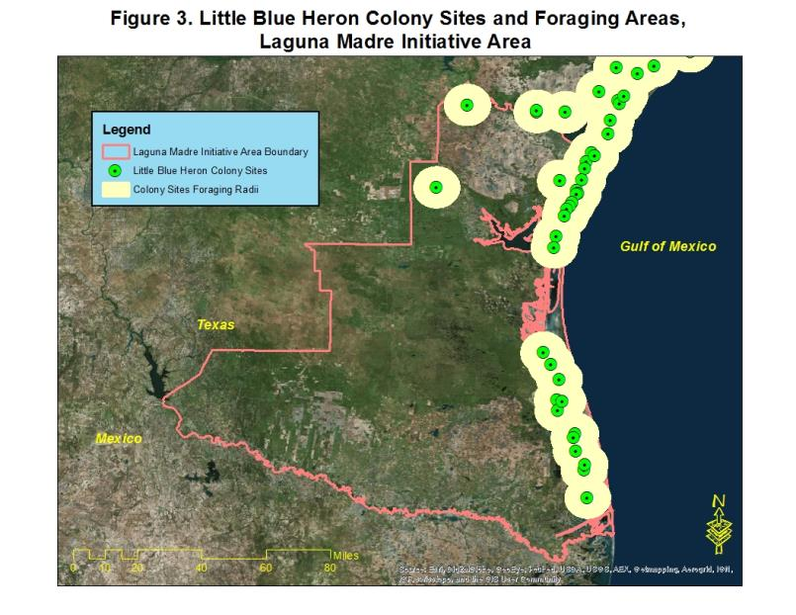

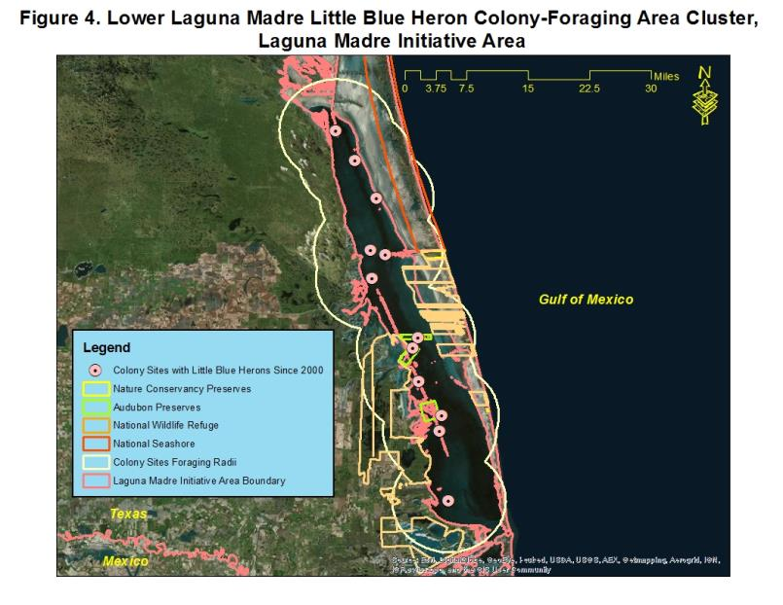

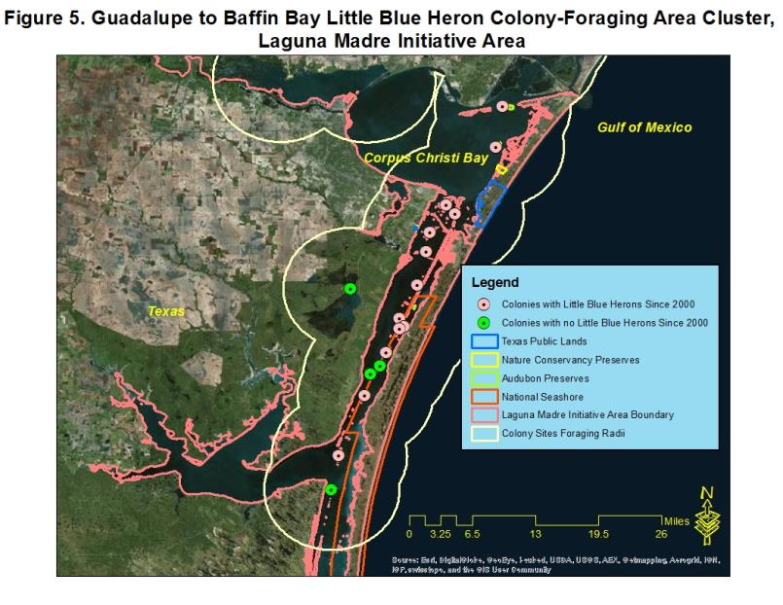

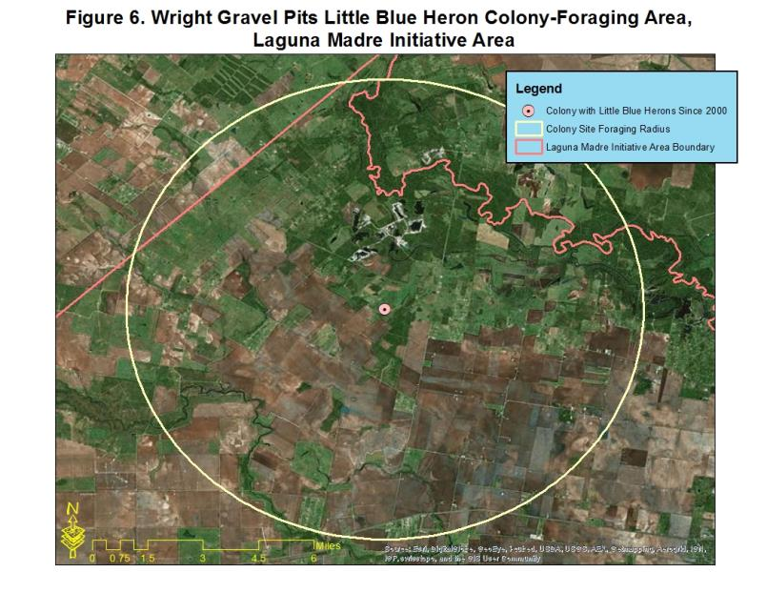

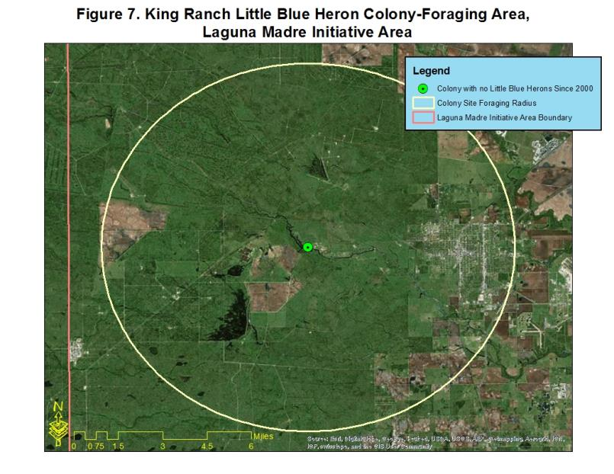

**Texas Mid-Coast Initiative Area**

**Little Blue Heron population estimate: 4,114 pairs**

**Little Blue Heron population objective: 5,345 pairs**



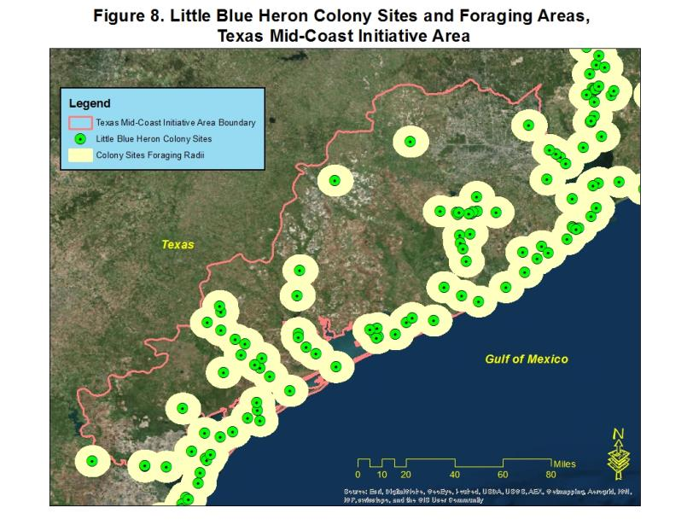

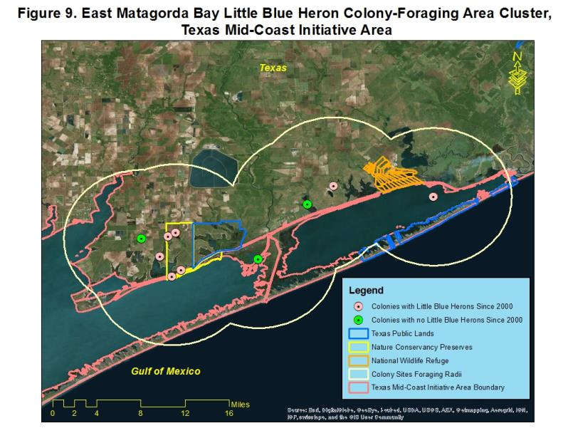

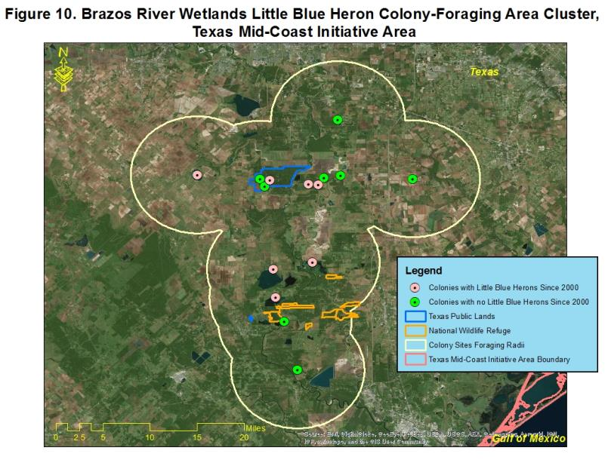

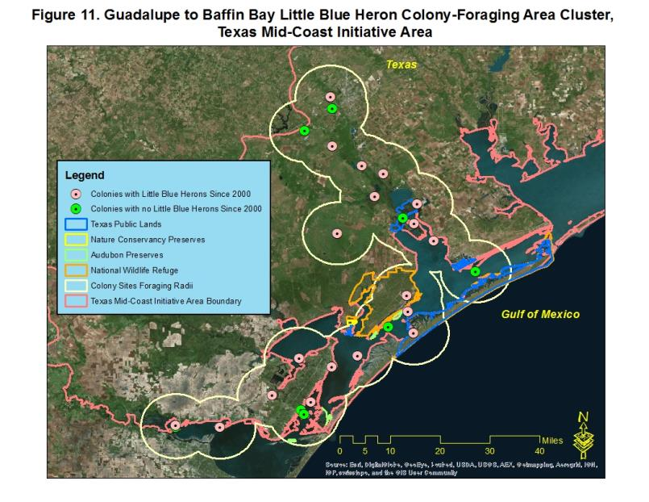

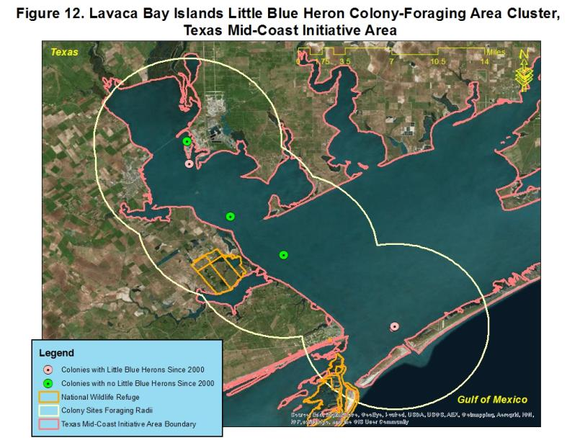

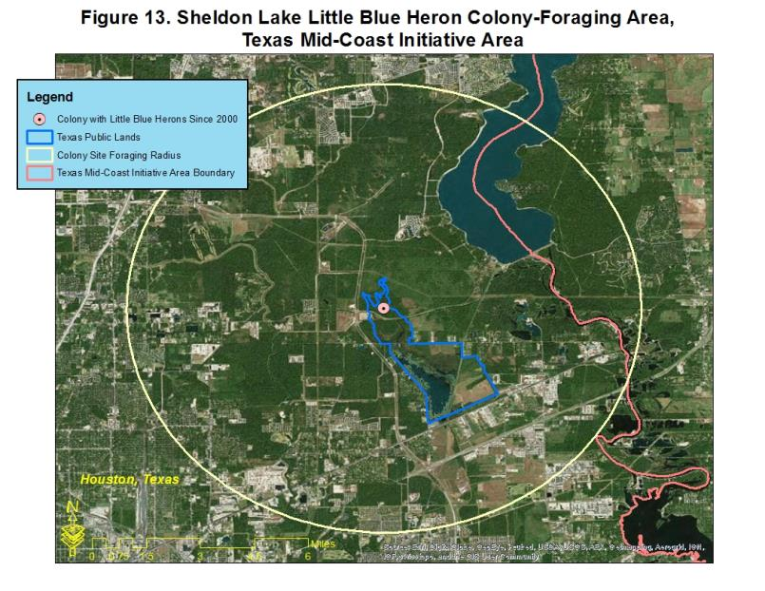

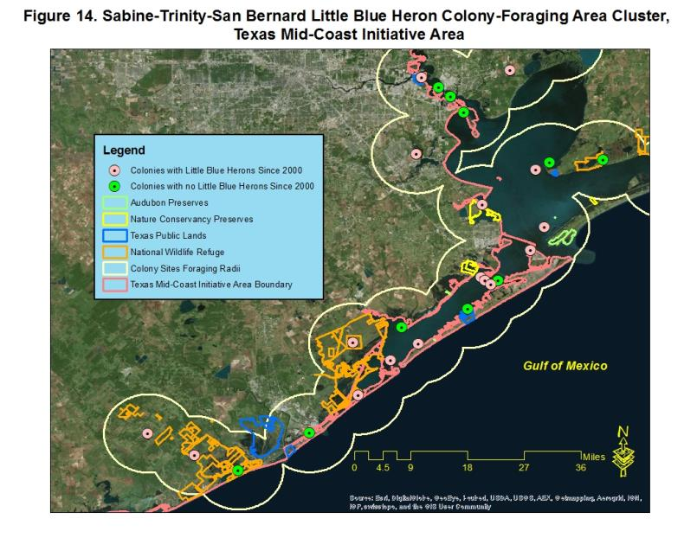

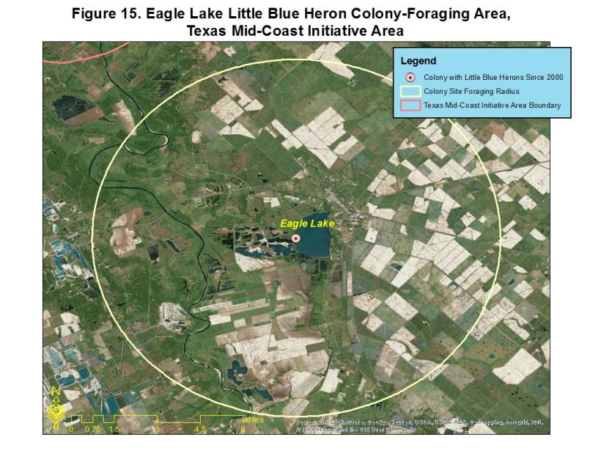

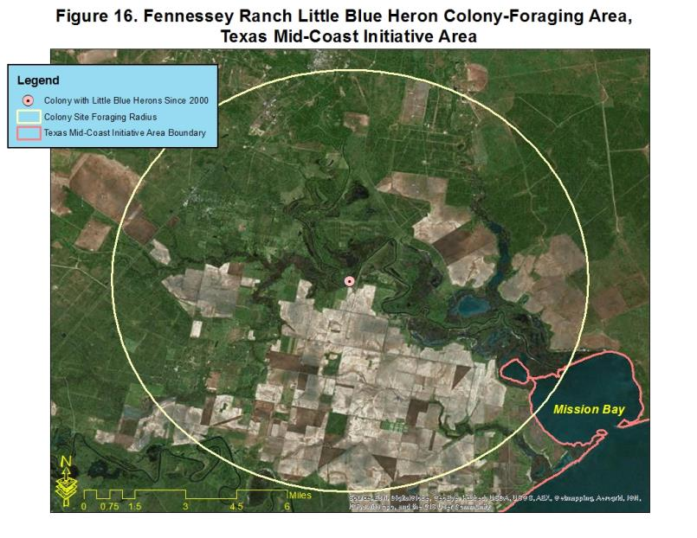

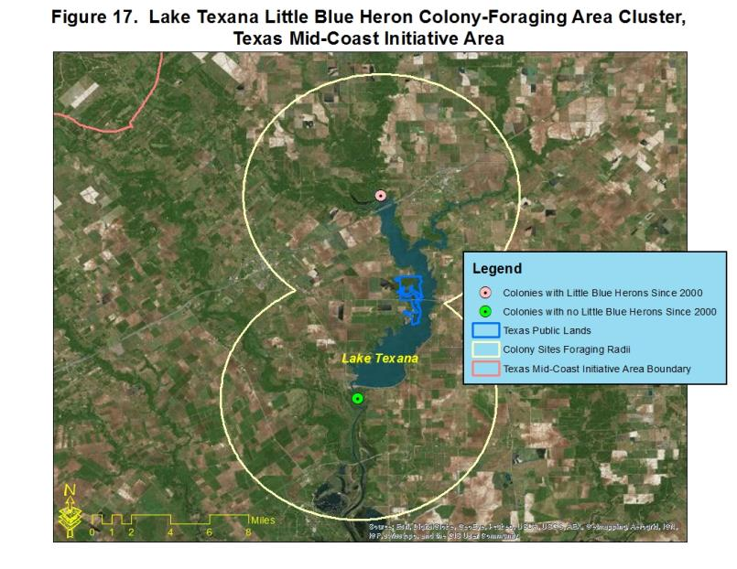

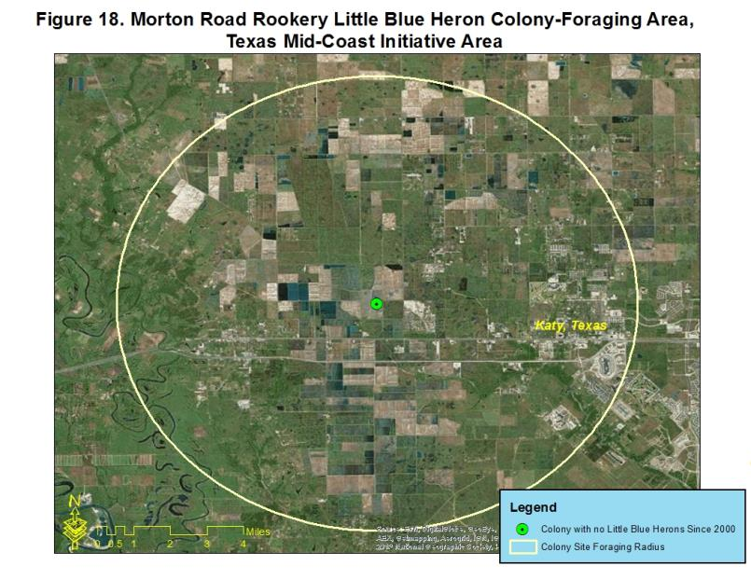

**Chenier Plain Initiative Area, Texas Portion**

**Little Blue Heron population estimate: 6,587 pairs**

**Little Blue Heron population objective: 8,562 pairs**



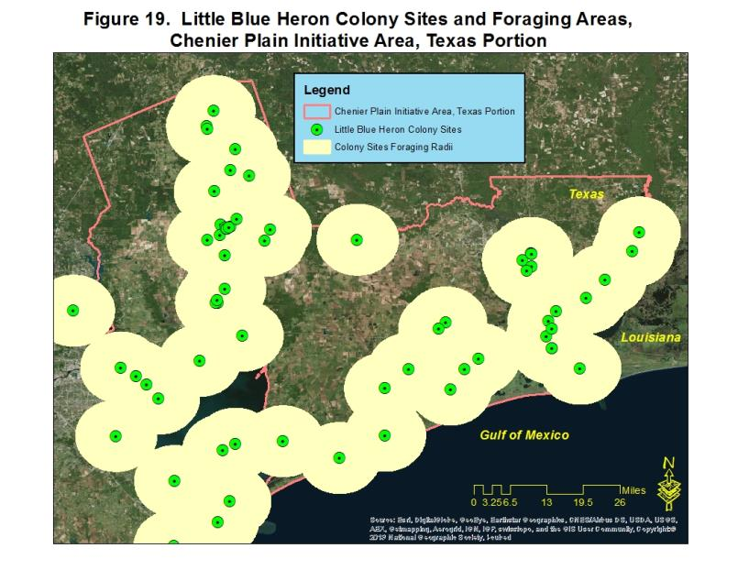

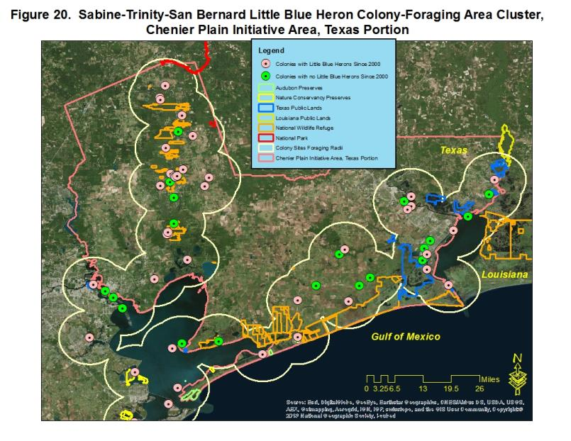

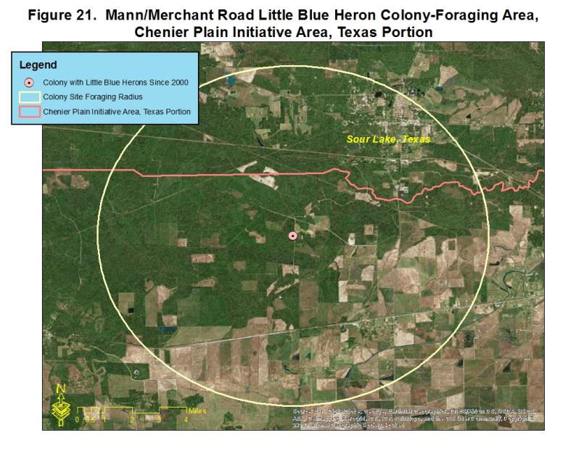

**Chenier Plain Initiative Area, Louisiana Portion**

**Little Blue Heron population estimate: 5,551 pairs**

**Little Blue Heron population objective: 7,217 pairs**



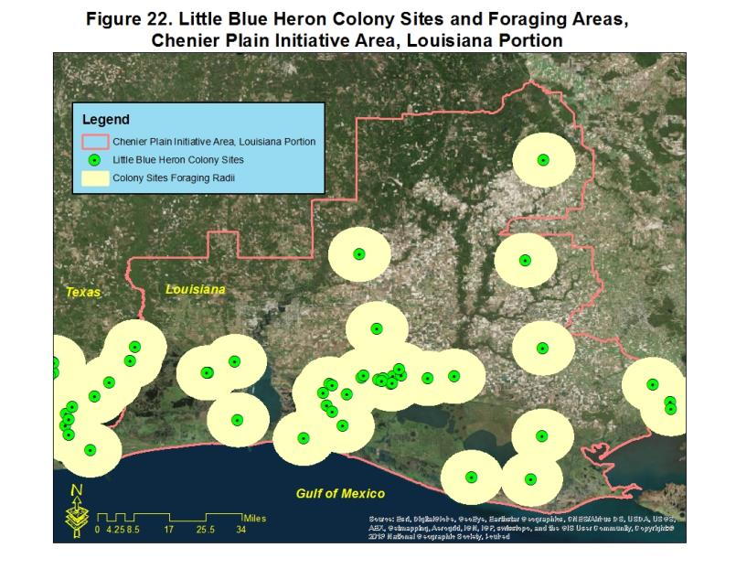

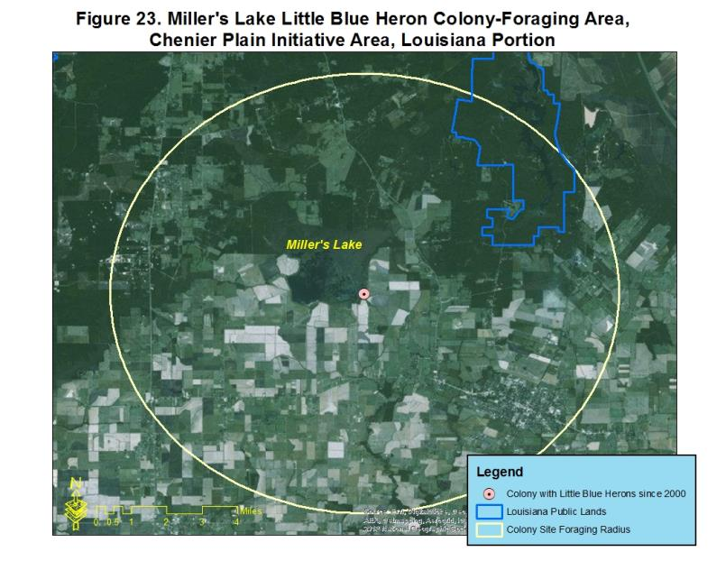

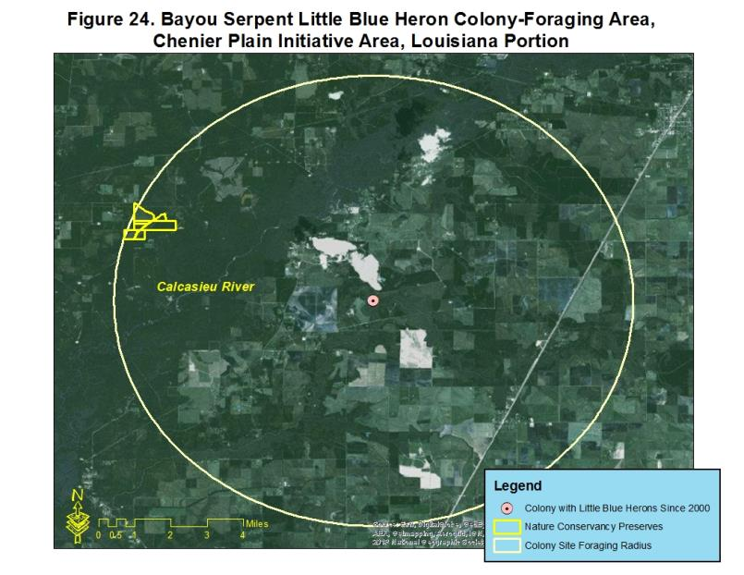

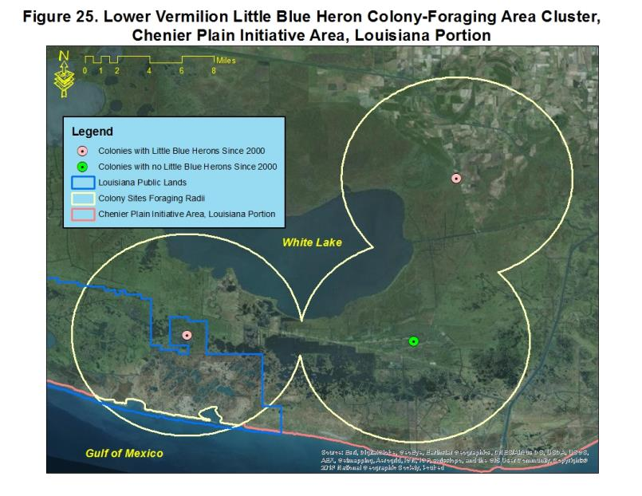

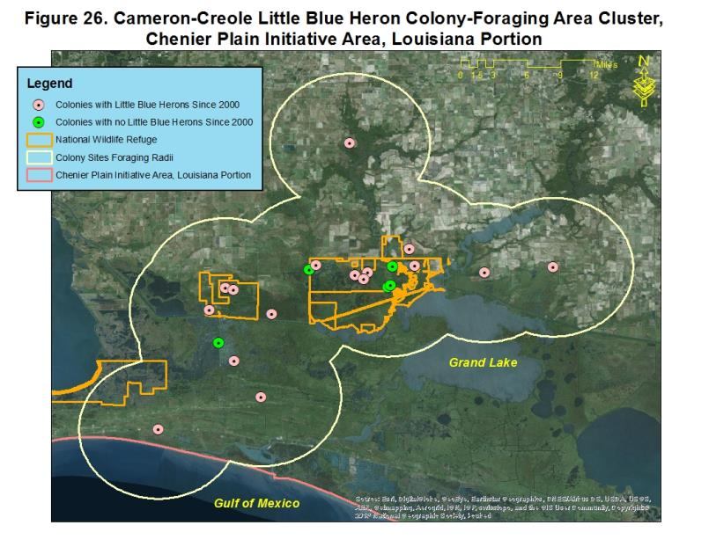

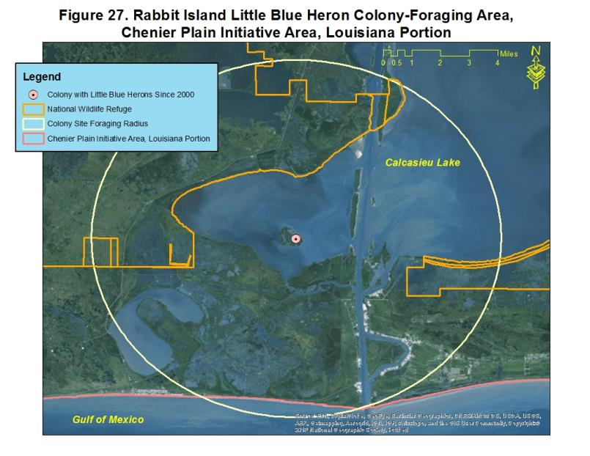

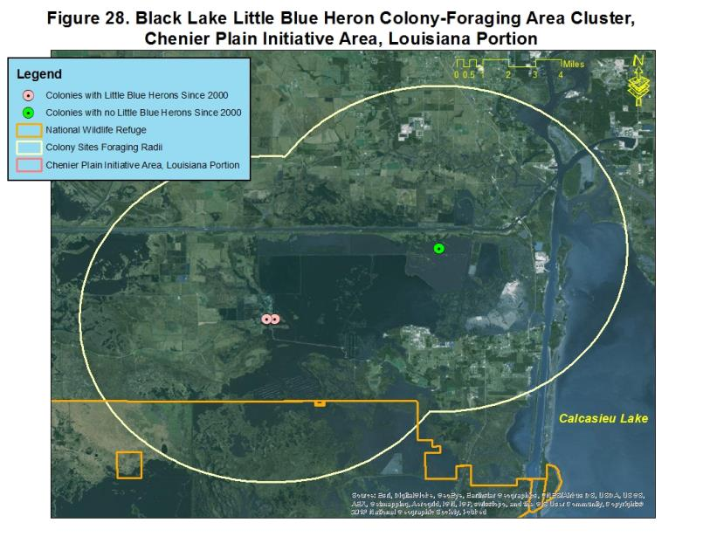

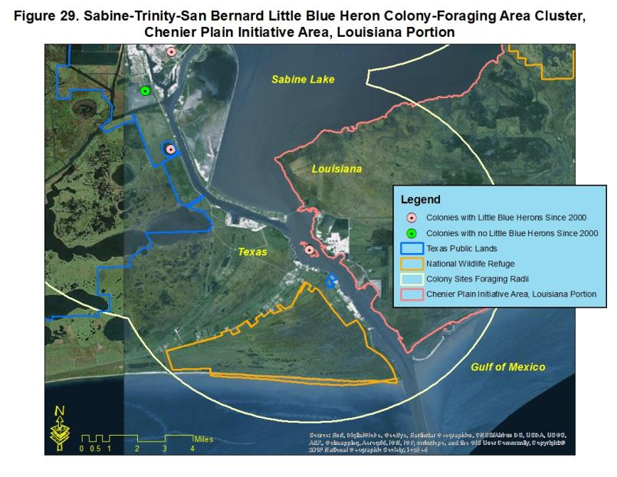

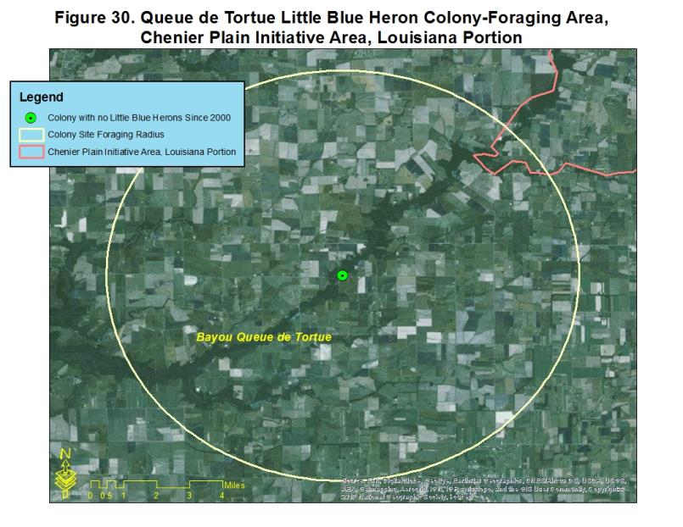

**Mississippi River Coastal Wetlands Initiative Area**

**Little Blue Heron population estimate: 4,813 pairs**

**Little Blue Heron population objective: 6,254 pairs**



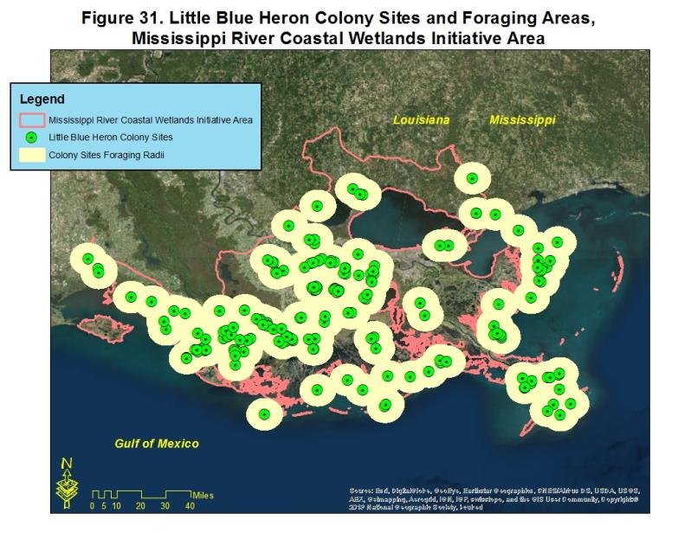

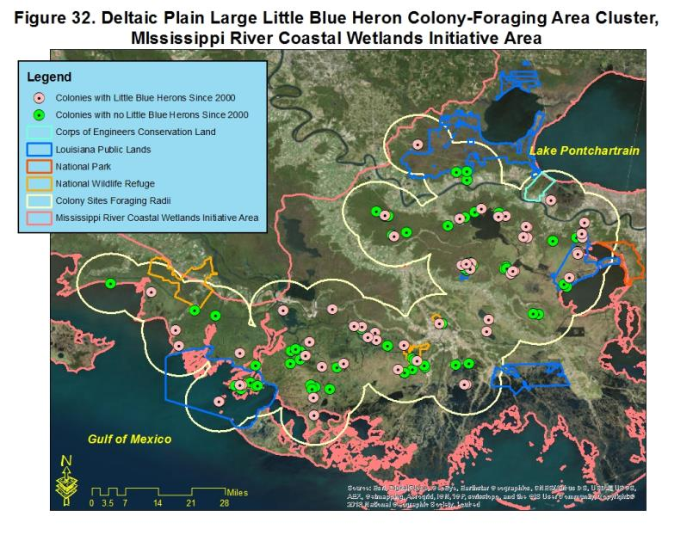

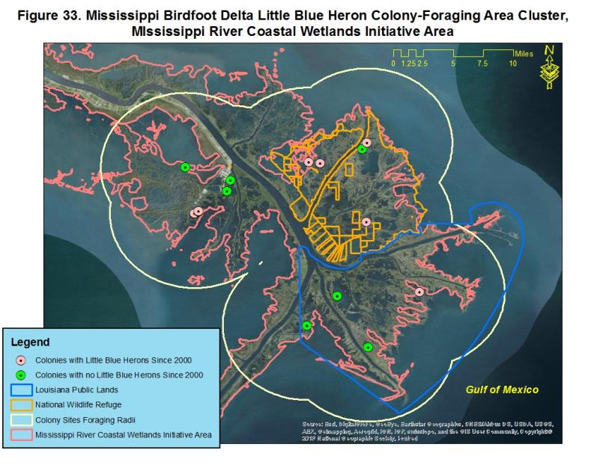

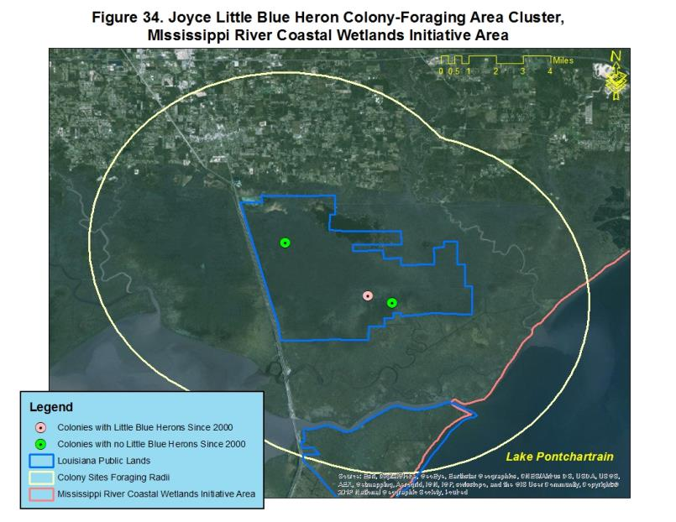

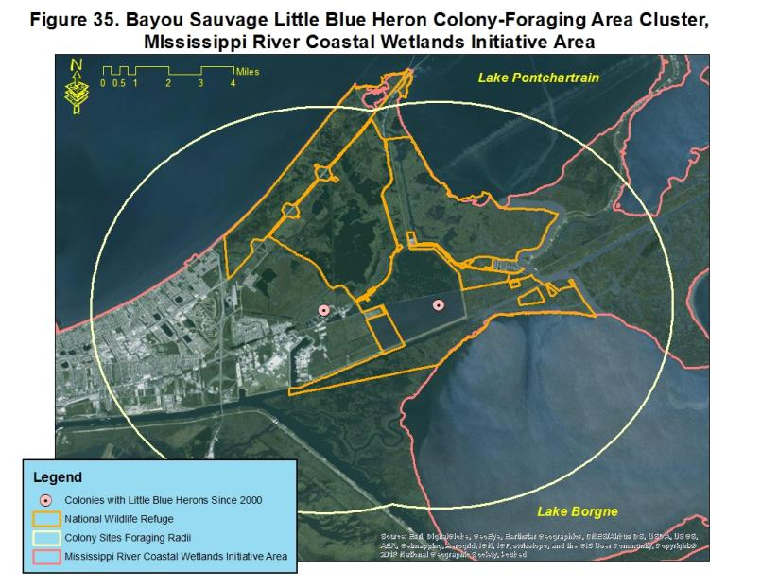

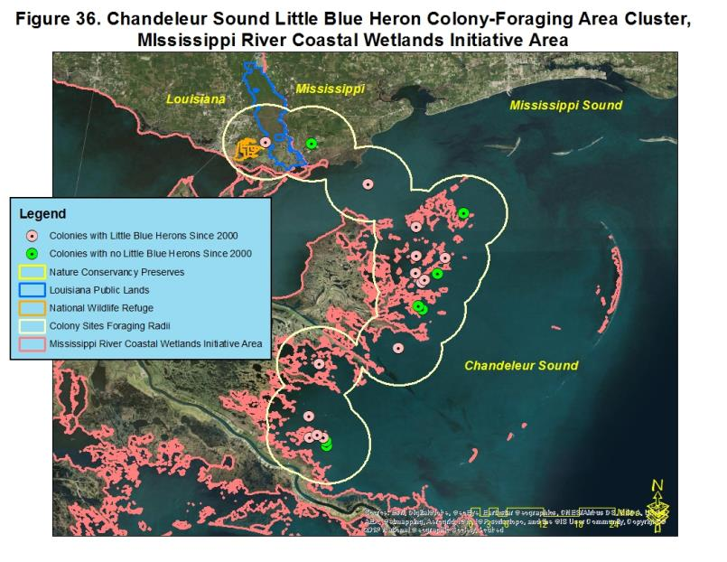

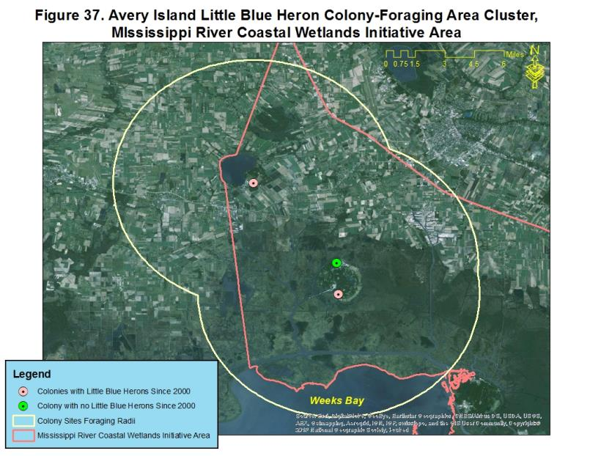

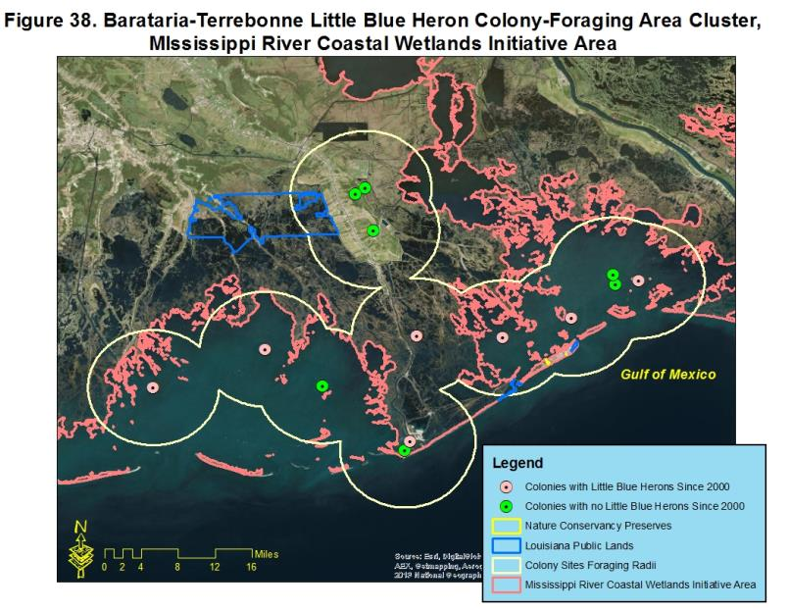

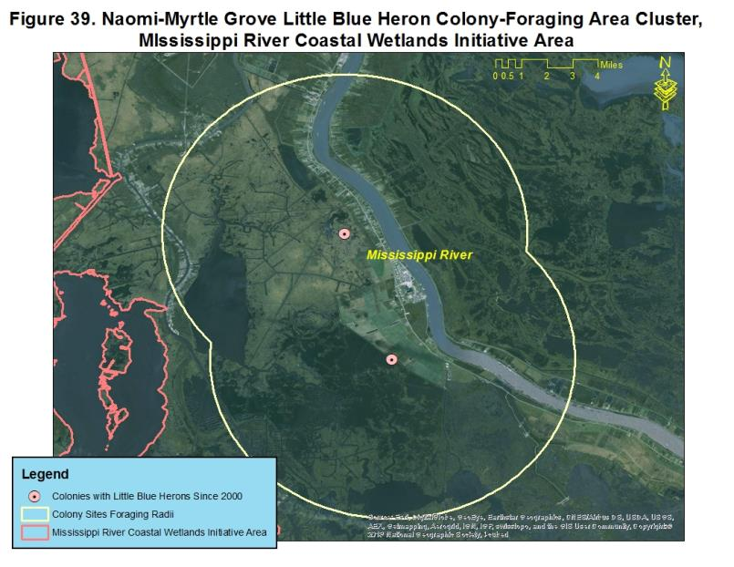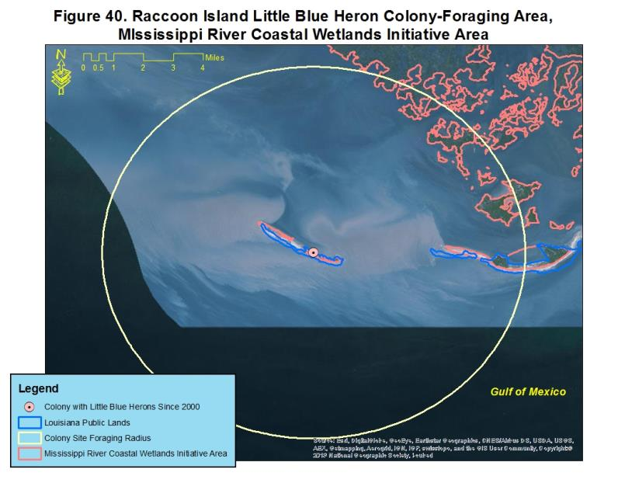

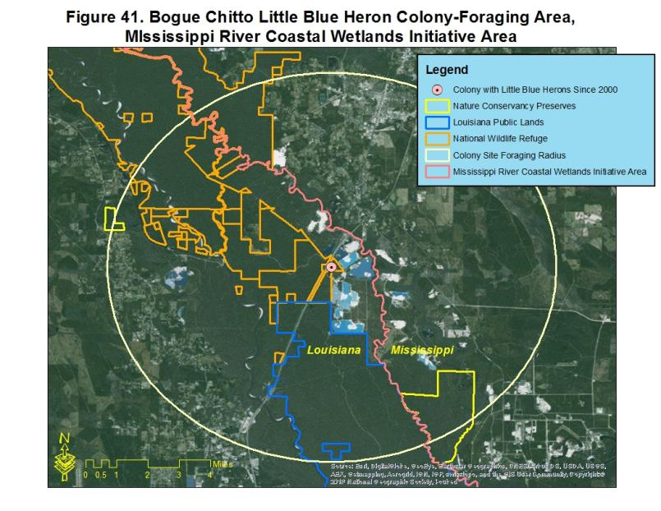

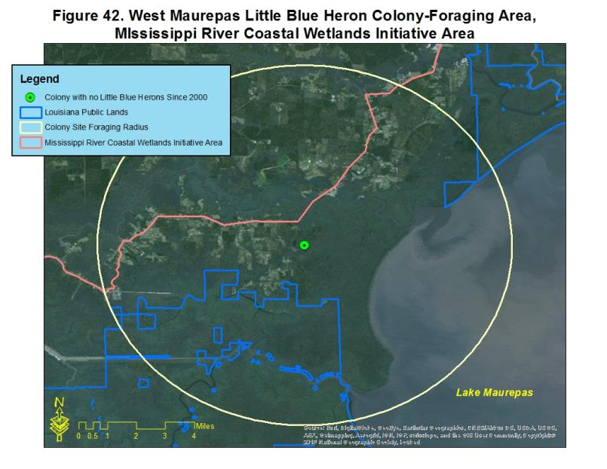

**Coastal Mississippi-Alabama Initiative Area**

**Little Blue Heron population estimate: 74 pairs**

**Little Blue Heron population objective: 96 pairs**



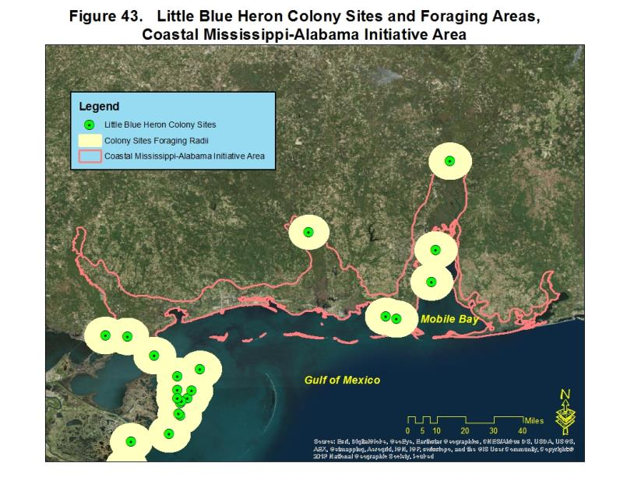

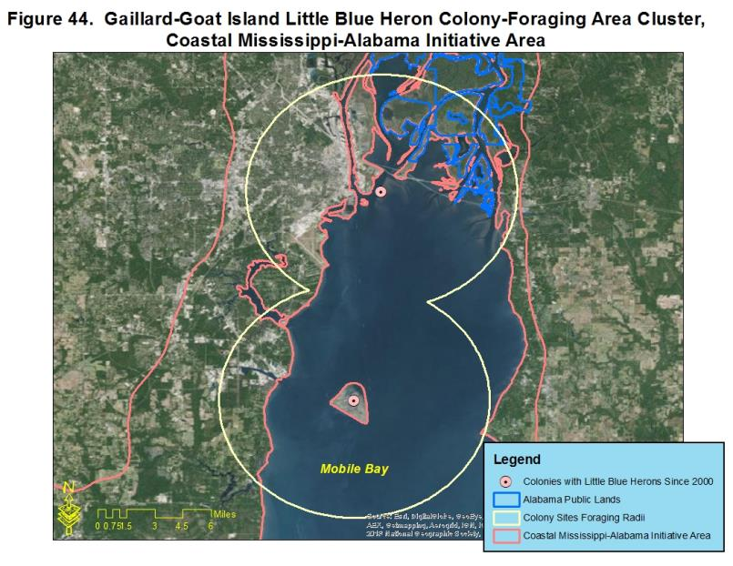

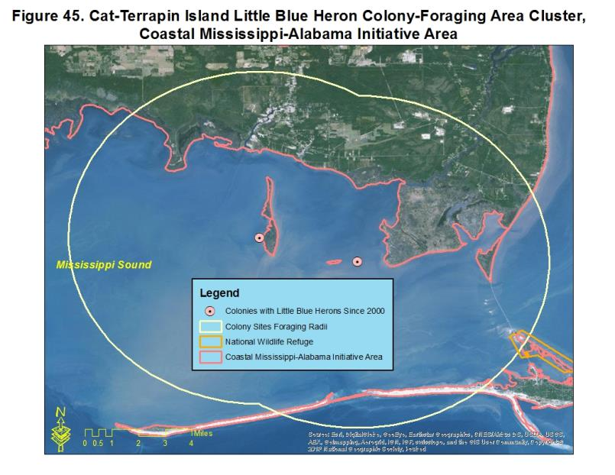

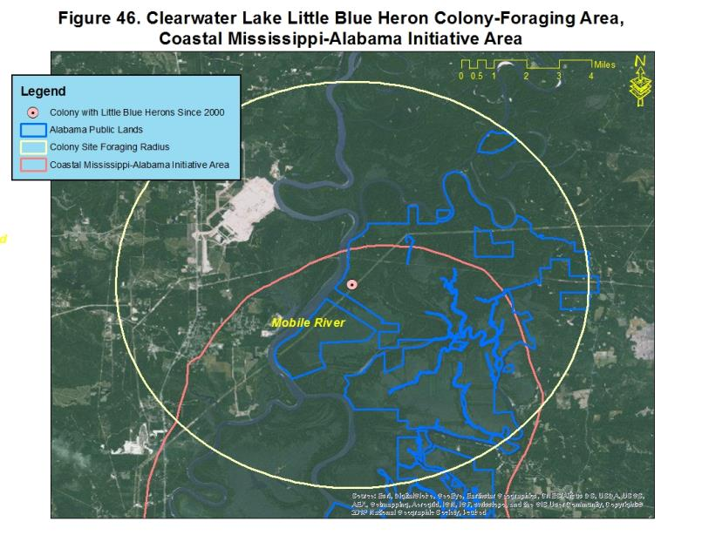

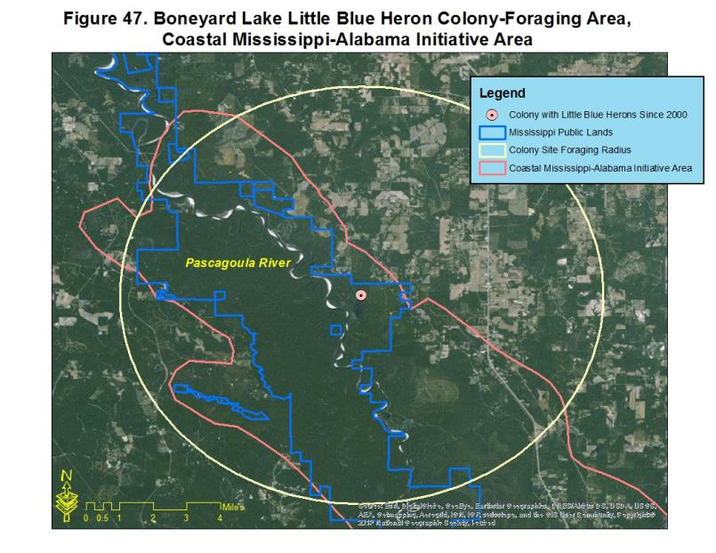

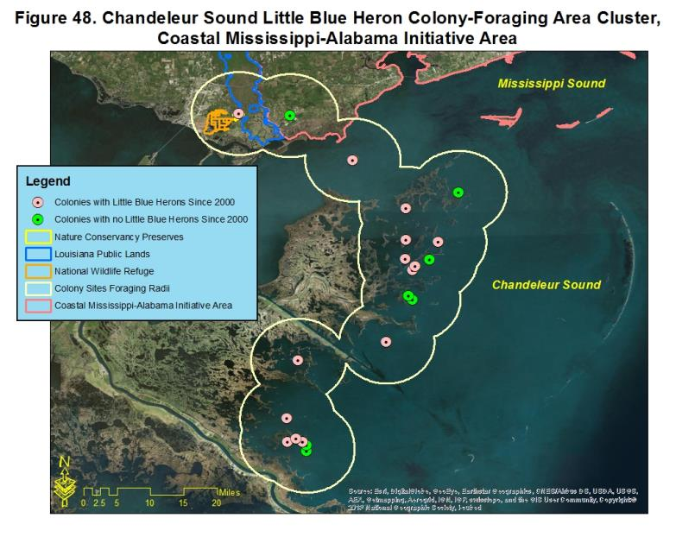

**Acknowledgements**

This document benefitted from the input of current and former members of the GCJV Waterbird Working Group: Dr. Clay Green, Dr. Sammy King, Dr. Paul Leberg, Richard Martin, David Newstead, Dr. Brent Ortego, and with additional assistance from Dr. Michael Brasher, Roger Clay, Dr. Steve DeMaso, Dr. Jeffrey Gleason, Michael Seymour, Kelli Stone, Barry Wilson, and Nick Winstead.

**Literature Cited**

American Ornithologists’ Union. 1983. Check-list of North American birds. 6th edition. American Ornithologists’ Union, Washington, D.C.

Baker, R.H. 1940. Crow depredation on heron nesting colonies. Wilson Bulletin 52: 124-125.

Bancroft, G.T., S.D. Jewell, and A.M. Strong. 1990. Foraging and nesting ecology of herons in the lower everglades relative to water conditions. Final report to South Florida Water Management District, West Palm Beach, FL.

Burger, J. 1978a. Competition between Cattle Egrets and native North American herons, egrets, and ibises. Condor 80: 15-23.

Burger, J. 1978b. The pattern and mechanism of nesting in mixed-species heronries. Pages 45-58 *in* Wading birds (A. Sprunt IV, J.C. Ogden, and S. Winckler, eds.). Research Report No. 7, National Audubon Society, New York.

Burger, J. and M. Gochfeld. 1988. Effects of ecotourists on bird behavior at Loxahatchee National Wildlife Refuge, Florida. Environmental Conservation 25(1): 13-21.

Burtner, B.F. 2011. Symbiosis between long legged wading birds (Ciconiiformes) and alligators (*Alligator* mississippiensis)? Testing the nest protector hypothesis. Masters Thesis, University of Florida. 67 pp.

Butler, R.W., J.A. Kushlan, and I.J. Davidson. 2000. Herons in North America, Central America and the West Indies. Pages 151-175 *in:* Heron Conservation (J.A. Kushlan and H. Hafner, Eds.). Academic Press, London.

Byrd, M.A. 1978. Dispersal and movements of six North American ciconiiforms. Pages 161-185 *in* Wading birds (A. Sprunt IV, J.C. Ogden, and S. Winckler, eds.). Research Report No. 7, National Audubon Society, New York.

Chaney, A. H. and G. W. Blacklock. 2005. Colonial waterbird and rookery island management plan. Coastal Bend Bays and Estuaries Program, Corpus Christi, TX. Available at: <http://www.cbbep.org>

Coffey, B.B., Jr. 1943. Post-juvenal migration of herons. Bird Banding 14:34-39.

Custer, T.W., and R.G. Osborn. 1978. Feeding habitat use by colonially-breeding herons, egrets, and ibises in North Carolina. Auk 95: 733-743.

Dubowy, P.J. 1996. Effects of water levels and weather on wintering herons and egrets. Southwestern Naturalist 41(4): 341-347.

Ducks Unlimited. 2013. Accesssed at: www.ducks.org/texas/ongoing-drought-forces-second-year-of-water-withheld-from-texas-rice-growers

Dusi, J.L. 1957. Dispersion of Little Blue Herons from a pond in Macon County, Alabama. Alabama Birdlife 5:9-11.

Dusi, J.L. 1967. Migration in the Little Blue Heron. Wilson Bulletin 79:223-235.

Dusi, J.L. 1968. The competition between Cattle Egrets and Little Blue Herons. Alabama Birdlife 16: 4-6.

Dusi, J.L., and R.T. Dusi. 1968. Ecological factors contributing to nesting failure in a heron colony. Wilson Bulletin 80: 458-466.

Elphick, C.S., O. Taft, and P.M. Lourenço. 2010. Management of rice fields for birds during the non-growing season. Waterbirds 33 (sp1): 181-192.

Erwin, R.M. 1989. Responses to human intruders by birds nesting in colonies: experimental results and management guidelines. Colonial Waterbirds 12:104-108.

Erwin, R.M., and R.A. Beck. 2007. Restoration of waterbird habitats in Chesapeake Bay: great expectations or *Sisyphus* revisted? Waterbirds 30(1): 163-176.

Fleury, B.E., and T.W. Sherry. 1995. Long-term population trends of colonial wading birds in the southern United States: the impact of crayfish aquaculture on Louisiana populations. Auk 112(3): 613-632.

Frederick. P.C. 2006. Recommendations for monitoring breeding populations of long legged waders (herons, egrets, ibises, storks, spoonbills, order Ciconiiformes). Pages I-1 – I-18 *in* Hunter, W.C., Golder, W., Melvin, S., and J. Wheeler. 2006. Southeast United States regional waterbird conservation plan. Available at: http://www.waterbirdconservation.org/southeast_us.html

Frederick, P.C., and M.W. Collopy. 1989. Nestling success of five ciconiiform species in relation to water conditions in the Florida everglades. Auk 106: 625-635.

Fredrickson, L.H., and T.S. Taylor (2007). Management of seasonally flooded impoundments for wildlife. Pages 8-18 *in* Wetland management for waterfowl handbook (K.D. Nelms, Ed.). Mississippi River Trust, Natural Resources Conservation Service, and United States Fish and Wildlife Service. Accessed at: <http://www.ms.nrcs.usda.gov/technical/NRCS%20Wetland%20Mgt%20for%20Waterfowl.pdf>

Green, M.C., M.C. Luent, T.C. Michot, C.W. Jeske, and P.L. Leberg. 2008. Comparison and assessment of aerial and ground estimates of waterbird colonies. Journal of Wildlife Management 72(3): 697-706.

Hafner, H. 1982. Creation of a breeding site for tree-nesting herons in the Camargue, France. Pages 216-220 *in* Manual of active wetland and waterfowl management (D. Scott, Ed.). IWRB, Slimbridge, UK.

Hamel, P. B. 1992. Land manager’s guide to the birds of the South. The Nature Conservancy, Southeastern Region, Chapel Hill, NC. 437 pp.

Hunter, W.C., W. Golder, S. Melvin, and J. Wheeler. 2006. Southeast United States regional waterbird conservation plan. Available at: http://www.waterbirdconservation.org/southeast_us.html

Jenni, D.A. 1969. A study of the ecology of four species of herons during the breeding season at Lake Alice, Alachua County, Florida. Ecological Monographs 39:245-270.

Knoder, C.E., P.D. Plaza, and A. Sprunt, IV. 1980. Status and distribution of the Jabiro Stork and other wading birds in western Mexico. Pages 58-127 *in* Proc. Natl. Audubon Soc. Symp., the birds of Mexico: their ecology and conservation (P.P. Schaeffer and S.M. Ehlers, Eds.). National Audubon Society, New York.

Kushlan, J.A., M.J. Steinkamp, K.C. Parsons, J. Capp, M.A, Cruz, M. Coulter, I. Davidson, L. Dickson, N. Edelson, R. Elliot, R.M. Erwin, S. Hatch, S. Kress, R. Milko, S. Miller, K. Mills, R. Paul, R. Phillips, J.E. Saliva, B. Sydeman, J. Trapp, J. Wheeler, and K. Wohl. 2002. Waterbird conservation for the Americas: the North American waterbird conservation plan, version 1. Waterbird Conservation for the Americas, Washington, D.C., 78 pp.

Landin, M.C. 1986. Building, developing and managing dredged material islands for bird habitat. U.S. Army Engineer Waterways Experiment Station, Publication EEDP-07-1.

Louisiana State University AgCenter. 2013. Estimated Louisiana crawfish harvest statistics, 1978 through 2011. Accessed at: [www.lsuagcenter.com/en/crops_livestock/aquaculture/crawfish/Industry+Stats+Legislation/Estimated+Louisiana+Crawfish+Harvest+Statistics+1978+though+2011.htn](http://www.lsuagcenter.com/en/crops_livestock/aquaculture/crawfish/Industry+Stats+Legislation/Estimated+Louisiana+Crawfish+Harvest+Statistics+1978+though+2011.htn)

Lowery, G.H., Jr. 1974. Louisiana Birds. Louisiana Wild Life and Fisheries Commission, Louisiana State University Press, Baton Rouge, 651 pp.

Luent, M.C., M. Collins, C. Jeske, and P. Leberg. 2012. Prevalence of a potentially lethal parasite of wading birds in natural and agricultural wetlands in south Louisiana. Southeastern Naturalist 11(3): 415-422.

Martin, R.P. and G.D. Lester. 1991. Atlas and census of wading bird and seabird nesting colonies in Louisiana: 1990. Louisiana Department of Wildlife and Fisheries, Louisiana Natural Heritage Program. Special Publication No. 3. Baton Rouge, LA. 182 pp.

Meanley, B. 1955. A nesting study of the Little Blue Heron in eastern Arkansas. Wilson Bulletin 67:84-99.

Mikuska, T., J.A. Kushlan, and S. Hartley. 1998. Key areas for wintering North American herons. Colonial Waterbirds 21(2): 125-134.

Morales, G. 2000. Herons in South America. Pages 177-199 *in:*  Heron Conservation (J.A. Kushlan and H. Hafner, Eds.). Academic Press, London.

National Ecological Assessment Team. 2006. Strategic habitat conservation. Retrieved from: <http://www.fws.gov/landscape-conservation/pdf/SHCReport.pdf>

Newsom, J.D., T. Joanen, and R.J. Howard. 1987. Habitat suitability index models: American alligator. U.S. Fish and Wildlife Service Biological Report 82(10.136). 14 pp.

Olmos, F., and R. Silva e Silva. 2002. Breeding biology of the Little Blue Heron *(Egretta caerulea)* in southeastern Brazil. Ornitologia Neotropical 13(1): 17-30.

Parsons, K.C. 1994. The Pea Patch Island wader colony: a proactive plan for natural resource protection and management. Manomet Bird Observatory. First-year report to Delaware Department of Natural Resources, Manomet Bird Observatory, Manomet, MA.

Rodgers, J.A., Jr. 1980. Breeding ecology of the Little Blue Heron on the west coast of Florida, USA. Colonial Waterbirds 10:38-44.

Rodgers, J.A., Jr., and H.T. Smith. 1995. Set-back distances to protect nesting bird colonies from human disturbance in Florida. Conservation Biology 9:89-99.

Rodgers, J.A., Jr., and H.T. Smith. 1997. Buffer zone distances to protect foraging and loafing waterbirds from human disturbance in Florida. Wildlife Society Bulletin 25(1): 139-145.

Rodgers, J.A., Jr., and H.T. Smith. 2012. Little Blue Heron *(Egretta caerulea)*. *In* The Birds of North America, No. 145 (A. Poole and F. Gill, Eds.). The Academy of Natural Sciences, Philadelphia, and The American Ornithologists’ Union, Washington, D.C.

Rodgers, J.A., Jr., P.S. Kubilis, and S.A. Nesbitt. 2005. Accuracy of aerial surveys of waterbird colonies. Waterbirds 28(2): 230-237.

Roffe, T.J. 1988. *Eustrongylides* sp. epizootic in young common egrets *(Casmerodius albus)*. Avian Diseases 32(1): 143-147.

Root, T. 1988. Atlas of wintering North American birds, an analysis of Christmas bird count data. The University of Chicago Press, Chicago.

Sauer, J.R. J.E. Hines, J.E. Fallon, K.L. Pardieck, D.J. Ziolkowski, Jr., and W.A. Link. 2014. The North American breeding bird survey, results and analysis 1966-2013. Version 01.30.2015 USGS Patuxent Wildlife Research Center. Laurel, MD

Sizemore, G.C., and M.B. Main. 2012. Quality of flooded rice and fallow fields as foraging habitat for Little Blue Herons and Great Egrets in the Everglades agricultural area, USA. Waterbirds 35(3): 381-393.

Soots, R.F., Jr., and M.C. Landin. 1978. Development and management of avian habitat on dredged islands. Dredged Material Research Program, Technical Report DS-79-18, Office of the Chief of Engineers, Washington, D.C.

Soots, R.F., Jr., and J.F. Parnell. 1975. Ecological succession of breeding birds in relation to plant succession on dredge islands in North Carolina estuaries. Sea Grant Publication UNC-SG-75-27, Raleigh, NC. 91 pp.

Spalding, M.G., J.P. Smith, and D.J. Forrester. 1994. Natural and experimental infections of *Eustrongylides ignotus*: effect on growth and survival of nestling wading birds. Auk 111(2): 328-336.

Telfair, R.C., II, and D.A. Swepston. 1987. Analysis of banding and marking nestling Anhinga, Olivaceous Cormorants, Roseate Spoonbills, ibises, bitterns, herons, and egrets in Texas (1923-1983). Federal Aid Project W-103-R, Texas Parks and Wildlife Department, Austin.

United States Department of Agriculture, National Agricultural Statistics Service. 2013. Accessed at: [www.nass.usda.gov](http://www.nass.usda.gov)

United States Department of Agriculture, Natural Resources Conservation Service. 2013. Restoring America’s wetlands: a private lands conservation success story. Accessed at: http://www.nrcs.usda.gov/Internet/FSE_DOCUMENTS/stelprdb1045079.pdf

U.S. Department of the Interior, Fish and Wildlife Service, and Environment Canada. 1986. North American Waterfowl Management Plan. Retrieved from: <http://www.fws.gov/migratorybirds/pdf/management/NAWMP/OriginalNAWMP.pdf>

Vermillion, W.G., and B.C. Wilson. 2009. Gulf Coast Joint Venture Conservation Planning for Reddish Egret. Gulf Coast Joint Venture, Lafayette, LA. 18 pp.

Wiese, J.H., W.R. Davidson, and V.F. Nettles. 1977. Large scale mortality of nestling ardeids caused by nematode infection. Journal of Wildlife Diseases 13: 376 – 382.

Willard, D.E. 1977. The feeding ecology and behavior of five species of herons in southeastern New Jersey. Condor 79: 462-470.